BHARATIYA VIDYA BHAVAN

SENIOR SECONDARY SCHOOL VATTIYOORKAVU

**Project Report On**

**Future Opportunities and Career**

**Understanding System(FOCUS)**



For

SSCE 2023-24 Examination

[As a part of the Computer Science Course (083)]

### SUBMITTED BY

### Akhil Krishna A Pillai

### Vishnu S

### A Ajith

### Athul Krishna S

### Under the Guidance of:

**Mr. Sanil.S**

Computer Science Teacher

**CERTIFICATE**

This is to certify that the synopsis entitled future opportunities and career understanding system(FOCUS) is a Bonafede work done by Akhil Krishna A Pillai, Vishnu S, Athul Krishna S and A Ajith of class XII Session 2023-24 in partial fulfillment of CBSE’s Examination 2023-24 and has been carried out under my direct supervision and guidance. This synopsis or a similar synopsis on the topic has not been submitted for any other examination and does not form a part of any other course undergone by the candidate.

***Signature of Signature of Internal Examiner External Examiner***

**Principal**

1

2

# Acknowledgement

### I wish to express my sincere gratitude to Mr. Sanil S, for his

constant support, help and guidance which enabled me to prepare this synopsis successfully. I also thank Mr. Sunil Chacko, our Principal, who provided the technical support and cooperation without which the synopsis would not have been possible.

### My heartfelt thanks to my friends and group members. Last but not the least I thank the Almighty for clearing the way when the going got tough.

***A Ajith***

***Akhil Krishna A Pillai***

***Athul Krishna S***

***Vishnu S***

# INDEX

|  |  |  |
| --- | --- | --- |
| *Sl No:* | *Title:* | *Page No:* |
| **1.** | BRIEF OVERVIEW OF PROJECT | 1 |
| **2.** | HARDWARE AND SOFTWARE REQUIREMENTS | 2 |
| **3.** | INTRODUCTION TO PYTHON | 3 |
| **4.** | INTRODUCTION TO PROJECT | 4 |
| **5.** | OBJECTIVES AND SCOPE | 6 |
| **6.** | FEATURES | 6 |
| **7.** | THEORETICAL BASIS | 8 |
| **8.** | PYTHON CODE | 10 |
| **9.** | OUTPUT SCREEN | 17 |
| **10.** | FUTURE ENHANCEMENTS | 22 |
| **11.** | CONCLUSION | 23 |
| **12.** | ANNEXURE | 24 |
| **13.** | BIBLIOGRAPHY | 24 |

## BRIEF OVERVIEW OF PROJECT

The main objective of the python project on Future Opportunities and Career Understanding System is to make exploring the details of jobs, their related courses, and collages easier for students and to help students decide their career based off the information.

The project is built as user end program with Graphical User Interface(GUI), but changes can be made to the system by altering the database .

The purpose of the project is to make all the details students need to make an informed decision on their future available in a single space or to give an idea about the different options which are available for students after their 12th.

**INPUT DATA AND VALIDATION OF PROJECT**

1. All the details such as courses, collages, jobs etc are pre-determined but displaying the data is done on the basis of user input

2.Avoiding errors in data.

## HARDWARE AND SOFTWARE REQUIREMENTS

Operating System:

* + Windows 7 and above

Hardware:

* + Processor of Intel® Core™ i5-10210U CPU @ 1.60GHz 2.11GHz
  + Installed Ram of 4.00 GB
  + Display Resolution 1920 x 1080
  + 45.6 GB of available space on the hard disk
  + Keyboard and mouse or some other compatible pointing devices

Software:

* + Microsoft Word
  + Python(3.11,64bit)
  + MySQL(8.0)

## INTRODUCTION TO PYTHON

Python is a powerful, modern, high level programming language. It is an interpreted language as its programs are executed by the interpreter.

Python is a popular object-oriented language used for both stand–alone programs and scripting applications in a variety of domains.

Python is a flexible, portable, easy to learn and modifiable language. So, we are integrating MySQL with Python interface for executing any database application.

## INTRODUCTION TO PROJECT

The software program efficiently provides all the important information needed for choosing our career which saves a lot of hassle and makes deciding career options easier of students.

It maintains data via MySQL where the initial first execution of the program will create a

MySQL Database and add the data from separate files into it, and any subsequent execution will directly access the data from MySQL Database.

FOCUS uses GUI(Graphical User Interface) to make the program more interactive and user friendly.

Additionally, an aptitude test is provided to help the user self asses themselves to find out which subjects they excel or are weak at.

All these features make FOCUS the perfect app to help students decide their career themselves

The features included in this DBMS are as follows:

1. **Stream Option**: The user is provided the four basic stream options of 12th (Computer Science, Bio – Mathematics, Commerce and Humanities) all the other details are based on the user’s choice of the stream.
2. **Job Options**: This system provides tons of job options and its details (like average salary, description, etc) based on which stream the user opted for 12th
3. **Courses**: Following the details of the job, user is provided with options of different courses to choose from and their corresponding details.
4. **Colleges:** A multitude of options for collages is provided to the user along with their details

## OBJECTIVES AND SCOPE

* System for browsing career details
* Information about courses, jobs, colleges
* Efficient, Responsive, Interactive
* Ease to use, Real life applicable

The proposed software program can be used by people to browse all the important career details and discover new options with ease. Program maintenance is simple and new data can be added via MySQL

## FEATURES:

The FOCUS software program can be used by students browse all the important career details in one space with ease. The program has been built in the form of GUI and hence is very user friendly and easy to use. This program aims to aid students to pick proper career paths by providing them with adequate information.

## THEORETICAL BASIS

## The theoretical basis for FOCUS draws from the fact that a lot of students are confused about what to choose for their career and don’t have a tool to navigate through all of the information available on internet. It aims to help users make informed career decisions by providing them a way to browse through all the important details like jobs, salaries, colleges, courses etc and for them to get an idea about their future.

## It is grounded in accurate and reliable data. It enables users to compare different career options, and make informed decisions. It also has option for an aptitude test. The project FOCUS emphasizes user interactivity, user interface and ease of use so as to provide optimum user experience along with proper, accurate information.

## PYTHON CODE

**import database_creator**

**import mysql.connector as mc**

**import data_cs**

**import data_commerce**

**import data_humantities**

**import customtkinter as ctk**

**import tkinter as tk**

**import json**

**import matplotlib.pyplot as plt**

**import anim**

**con = mc.connect(host = "localhost" , user = "root" , password = "password", database = database_creator.name)**

**cur = con.cursor()**

**if(database_creator.first_time == True):**

**cur.execute('''create table Computer_science**

**(Courses varchar(100) primary key)''')**

**cur.execute('''create table Bio_maths**

**(Courses varchar(100) primary key)''')**

**cur.execute('''create table Commerce**

**(Courses varchar(100) primary key)''')**

**cur.execute('''create table Humanities**

**(Courses varchar(100) primary key)''')**

**cur.execute('''create table Job_opportunity**

**(Name_of_job varchar(100) primary key not null,**

**Salary integer not null,**

**Description text)''')**

**cur.execute('''create table Colleges**

**(College Varchar(100) primary key not null,**

**State varchar(20),**

**Entrance varchar(20),**

**Courses text)''')**

**cur.execute('''create table Courses**

**(Courses varchar(100) primary key not null,**

**Job_opportunities text(10000) not null,**

**Description text,**

**Average_duration integer,**

**Colleges text)''')**

**print("created tables succesfully")**

**def insert_CS(course_list):**

**for i in course_list:**

**cur.execute("insert into Computer_science values('{}')".format(str(i)))**

**def insert_Bio(course_list):**

**for i in course_list:**

**cur.execute("insert into Bio_maths values('{}')".format(str(i)))**

**def insert_commerce(course_list):**

**for i in course_list:**

**cur.execute("insert into Commerce values('{}')".format(str(i)))**

**def insert_humanities(course_list):**

**for i in course_list:**

**cur.execute("insert into Humanities values('{}')".format(str(i)))**

**def insert_Job_opps(Jobs_dict):**

**for i in Jobs_dict:**

**cur.execute("insert into Job_opportunity values('{job_name}',{salary},'{desc}')".format(job_name = i, salary = str(Jobs_dict[i][0]), desc = Jobs_dict[i][1]))**

**def insert_colleges(college_dict):**

**for i in college_dict:**

**cur.execute("insert into Colleges values('{collage_name}','{state}','{entrance}','{courses}')".format(collage_name = i, state = college_dict[i][0], entrance = college_dict[i][1], courses = str(college_dict[i][2])))**

**def insert_courses(course_dict):**

**for i in course_dict:**

**cur.execute("insert into Courses values('{course_name}','{job_opps}','{desc}',{duration},'{colleges}')".format(course_name = i, job_opps = str(course_dict[i][0]), desc = course_dict[i][1], duration = course_dict[i][2], colleges = str(course_dict[i][3])))**

**insert_commerce(data_commerce.course_list_Commerce)**

**insert_Job_opps(data_commerce.Jobs_dict_Commerce)**

**insert_colleges(data_commerce.college_dict_Commerce)**

**insert_CS(data_cs.course_list_cs)**

**insert_Job_opps(data_cs.Jobs_dict_cs)**

**insert_colleges(data_cs.college_dict_cs)**

**insert_courses(data_cs.course_dict_cs)**

**insert_courses(data_commerce.course_dict_Commerce)**

**insert_humanities(data_humantities.course_list_humantities)**

**insert_Job_opps(data_humantities.Jobs_dict_humantities)**

**insert_colleges(data_humantities.college_dict_humantities)**

**insert_courses(data_humantities.course_dict_humantitse)**

**con.commit()**

**window = ctk.CTk()**

**window.geometry("1000x800")**

**window.title("FOCUS")**

**ctk.set_default_color_theme("green")**

**notebook = ctk.CTkTabview(window)**

**custom_font = ctk.CTkFont("<Times New Roman",20)**

**notebook._segmented_button.configure(font=custom_font)**

**Focus_tab = notebook.add("Focus")**

**Aptitude_tab = notebook.add("Aptitude Test")**

**Credits_tab = notebook.add("Credits")**

**def focus():**

**def start_button_remove():**

**start_button.place_forget()**

**start_label.place_forget()**

**def remove_buttons():**

**cs_button.place_forget()**

**bio_button.place_forget()**

**com_button.place_forget()**

**hum_button.place_forget()**

**heading.place_forget()**

**def cs_pressed():**

**remove_buttons()**

**def remove_buttons_cs():**

**canvas_cs_press.pack_forget()**

**scrollbar_cs_press.place_forget()**

**def job_pressed(text):**

**remove_buttons_cs()**

**def remove_buttons_job():**

**job_slary_title.place_forget()**

**job_slary_content.place_forget()**

**job_desc_content.place_forget()**

**job_title.place_forget()**

**job_desc_content.place_forget()**

**check_courses_button.place_forget()**

**def check_courses_pressed():**

**remove_buttons_job()**

**def remove_buttons_checkcourse():**

**canvas_cous_press.pack_forget()**

**scrollbar_cous_press.place_forget()**

**def course_pressed(name_course):**

**remove_buttons_checkcourse()**

**def remove_buttons_course_detail():**

**canvas_cous_detail.pack_forget()**

**scrollbar_cous_detail.place_forget()**

**def collage_pressed(name_collage):**

**remove_buttons_course_detail()**

**def home_pressed():**

**collage_title.place_forget()**

**collage_entrance_title.place_forget()**

**collage_location_title.place_forget()**

**collage_course_list_title.place_forget()**

**collage_course_list_stuff.place_forget()**

**back_button.place_forget()**

**focus()**

**cur.execute("Select * from Colleges")**

**collage_data_list = cur.fetchall()**

**for i in collage_data_list:**

**if(i[0] == name_collage):**

**collage_data_act = list(i)**

**collage_state = collage_data_act[1]**

**collage_entrance = collage_data_act[2]**

**collage_course_list = json.loads(collage_data_act[3])**

**collage_course_list_content = ""**

**for i in collage_course_list:**

**collage_course_list_content = collage_course_list_content + i +", "**

**collage_course_list_content_act = ''**

**line_var = 0**

**for j in range(len(collage_course_list_content)-2):**

**line_var +=1**

**if( line_var > 70 and collage_course_list_content[j] == " "):**

**collage_course_list_content_act += '\n'**

**line_var = 0**

**collage_course_list_content_act += collage_course_list_content[j]**

**collage_title = ctk.CTkLabel(Focus_tab,corner_radius=10,text=name_collage+" Details:",font = ("<Times New Roman",30))**

**collage_entrance_title = ctk.CTkLabel(Focus_tab,corner_radius=10,text="Entrance exam: "+collage_entrance,font = ("<Times New Roman",25))**

**collage_location_title = ctk.CTkLabel(Focus_tab,corner_radius=10,text="College location: "+collage_state,font = ("<Times New Roman",25))**

**collage_course_list_title = ctk.CTkLabel(Focus_tab,corner_radius=10,text="Other available courses:",font = ("<Times New Roman",25))**

**collage_course_list_stuff = ctk.CTkLabel(Focus_tab,corner_radius=10,text=collage_course_list_content_act,font = ("<Times New Roman",20))**

**back_button = ctk.CTkButton(Focus_tab,corner_radius=10,text="Home",font = ("<Times New Roman",25),command=home_pressed)**

**collage_title.place(relx = 0.5, rely= 0.1, relwidth = 1,anchor = 'center')**

**collage_entrance_title.place(relx = 0.5, rely = 0.3, relwidth = 0.9,anchor = 'center')**

**collage_location_title.place(relx = 0.5, rely = 0.45, relwidth = 0.9,anchor = 'center')**

**collage_course_list_title.place(relx = 0.5, rely = 0.6, relwidth = 0.9,anchor = 'center')**

**collage_course_list_stuff.place(relx = 0.5, rely = 0.69,relwidth = 0.9,anchor='center')**

**back_button.place(relx=0.5,rely = 0.9,relwidth=0.3,anchor="center")**

**class collage_boottuns:**

**def __init__(self,txt):**

**self.txt = txt**

**self.collage_button_act = ctk.CTkButton(Focus_tab,corner_radius=10,text=self.txt, font = ("<Times New Roman",20),width=70,height=50,command=lambda:collage_pressed(self.txt))**

**for i in courses_full_data_lst:**

**if i[0] == name_course:**

**course_desc = ''**

**line_var = 0**

**for j in range(len(str(i[2]))):**

**line_var += 1**

**if( line_var > 70 and str(i[2])[j] == " " ):**

**course_desc += '\n'**

**line_var = 0**

**course_desc += str(i[2])[j]**

**course_duration = int(i[3])**

**course_collage_list = json.loads(i[4])**

**canvas_cous_detail = tk.Canvas(Focus_tab,scrollregion=(0,0,2000,5000),bg="#2a2b2a")**

**canvas_cous_detail.create_rectangle(0,0,canvas_cous_detail.winfo_width(),canvas_cous_detail.winfo_height(),fill='#2a2b2a')**

**canvas_cous_detail.pack(fill='both',expand=True)**

**scrollbar_cous_detail = tk.Scrollbar(Focus_tab,orient='vertical',command=canvas_cous_detail.yview,bg="#2a2b2a")**

**scrollbar_cous_detail.place(relx=1,rely=0,relheight=1,anchor='ne')**

**canvas_cous_detail.configure(yscrollcommand= scrollbar_cous_detail.set)**

**course_name_title = ctk.CTkLabel(Focus_tab,corner_radius=10,text=name_course+":",font = ("<Times New Roman",30))**

**course_desc_content = ctk.CTkLabel(Focus_tab,corner_radius=10,text=course_desc,font = ("<Times New Roman",20))**

**course_duration_title = ctk.CTkLabel(Focus_tab,corner_radius=10,text="Duration of "+name_course+": "+str(course_duration)+" years",font = ("<Times New Roman",25))**

**collage_list_title = ctk.CTkLabel(Focus_tab,corner_radius=10,text="Suitable Collages:",font = ("<Times New Roman",30))**

**canvas_cous_detail.create_window((550,100),window=course_name_title)**

**canvas_cous_detail.create_window((550,200),window=course_desc_content)**

**canvas_cous_detail.create_window((550,300),window=course_duration_title)**

**canvas_cous_detail.create_window((550,400),window=collage_list_title)**

**x=550**

**y=500**

**for i in course_collage_list:**

**collage_button = collage_boottuns(str(i))**

**canvas_cous_detail.create_window((x,y),window=collage_button.collage_button_act)**

**y+=150**

**class course_boottuns:**

**def __init__(self,txt):**

**self.txt = txt**

**self.course_button_act = ctk.CTkButton(Focus_tab,corner_radius=10,text=self.txt, font = ("<Times New Roman",25),width=100,height=50,command=lambda:course_pressed(self.txt))**

**canvas_cous_press = tk.Canvas(Focus_tab,scrollregion=(0,0,2000,5000),bg="#2a2b2a")**

**canvas_cous_press.create_rectangle(0,0,canvas_cous_press.winfo_width(),canvas_cous_press.winfo_height(),fill='#2a2b2a')**

**canvas_cous_press.pack(fill='both',expand=True)**

**scrollbar_cous_press = tk.Scrollbar(Focus_tab,orient='vertical',command=canvas_cous_press.yview,bg="#2a2b2a")**

**scrollbar_cous_press.place(relx=1,rely=0,relheight=1,anchor='ne')**

**canvas_cous_press.configure(yscrollcommand= scrollbar_cous_press.set)**

**course_title = ctk.CTkLabel(Focus_tab,text = "The courses most suitable\nfor "+name_job+" are:",font = ("<Times New Roman",30),corner_radius=10)**

**canvas_cous_press.create_window((550,100),window=course_title)**

**cur.execute("Select * from Courses")**

**data_job_press = cur.fetchall()**

**courses_full_data_lst = []**

**for i in data_job_press:**

**if name_job in json.loads(i[1]):**

**courses_full_data_lst.append(i)**

**x=550**

**y=250**

**for i in courses_full_data_lst:**

**j = i[0]**

**course_button = course_boottuns(str(j))**

**canvas_cous_press.create_window((x,y),window=course_button.course_button_act)**

**y+=150**

**cur.execute("select * from Job_opportunity")**

**jobs_data = cur.fetchall()**

**for i in jobs_data:**

**if(i[0] == text):**

**name_job = i[0]**

**avg_salary = i[1]**

**job_desc = ''**

**line_var = 0**

**for j in range(len(i[2])):**

**line_var += 1**

**if(line_var > 70 and i[2][j] == " "):**

**job_desc += '\n'**

**line_var = 0**

**job_desc += i[2][j]**

**job_title = ctk.CTkLabel(Focus_tab,corner_radius=10,text=name_job+":",font = ("<Times New Roman",30))**

**job_slary_title = ctk.CTkLabel(Focus_tab,corner_radius=10,text="Average Salary:",font = ("<Times New Roman",30))**

**job_slary_content = ctk.CTkLabel(Focus_tab,corner_radius=10,text=str(avg_salary),font = ("<Times New Roman",25))**

**job_desc_content = ctk.CTkLabel(Focus_tab,corner_radius=10,text=job_desc,font = ("<Times New Roman",25))**

**check_courses_button = ctk.CTkButton(Focus_tab,corner_radius=10,text="Check related courses",font = ("<Times New Roman",30),command = check_courses_pressed)**

**job_title.place(relx = 0.0, rely= 0.1, relwidth = 0.5,anchor = 'w')**

**job_desc_content.place(relx = 0.0, rely = 0.25, relwidth = 1,anchor = 'w')**

**job_slary_title.place(relx = 0.0, rely = 0.5, relwidth = 0.5,anchor = 'w')**

**job_slary_content.place(relx = 0.0, rely = 0.6, relwidth = 0.5,anchor = 'w')**

**check_courses_button.place(relx = 0.5, rely = 0.85,relwidth = 0.6,anchor='center')**

**class job_boottuns:**

**def __init__(self,txt):**

**self.txt = txt**

**self.job_button_act = ctk.CTkButton(Focus_tab,corner_radius=10,text=self.txt, font = ("<Times New Roman",20),width=100,height=50,command=lambda:job_pressed(self.txt))**

**canvas_cs_press = tk.Canvas(Focus_tab,scrollregion=(0,0,2000,5000),bg="#2a2b2a")**

**canvas_cs_press.create_rectangle(0,0,canvas_cs_press.winfo_width(),canvas_cs_press.winfo_height(),fill='#2a2b2a')**

**canvas_cs_press.pack(fill='both',expand=True)**

**scrollbar_cs_press = tk.Scrollbar(Focus_tab,orient='vertical',command=canvas_cs_press.yview,bg="#2a2b2a")**

**scrollbar_cs_press.place(relx=1,rely=0,relheight=1,anchor='ne')**

**canvas_cs_press.configure(yscrollcommand= scrollbar_cs_press.set)**

**heading_cs_press = ctk.CTkLabel(Focus_tab,corner_radius=10,text="These are the best possible\njobs after Computer science",font = ("<Times New Roman",30))**

**canvas_cs_press.create_window((550,100),window=heading_cs_press)**

**cur.execute("select * from Computer_science")**

**course_list_cs_raw = cur.fetchall()**

**course_list_cs = []**

**for i in course_list_cs_raw:**

**course_list_cs.append(i[0])**

**cur.execute("select * from Courses")**

**course_list_data = cur.fetchall()**

**jobs_list_cs_raw = []**

**jobs_list_cs = []**

**for i in course_list_data:**

**if(i[0] in course_list_cs):**

**jobs_list_cs_raw.append(i[1])**

**for i in jobs_list_cs_raw:**

**jobs_list_cs.extend(json.loads(i))**

**x=550**

**y=250**

**for i in jobs_list_cs:**

**job_button = job_boottuns(str(i))**

**canvas_cs_press.create_window((x,y),window=job_button.job_button_act)**

**y+=150**

**def bio_pressed():**

**remove_buttons()**

**def remove_buttons_cs():**

**canvas_cs_press.pack_forget()**

**scrollbar_cs_press.place_forget()**

**def job_pressed(text):**

**remove_buttons_cs()**

**def remove_buttons_job():**

**job_slary_title.place_forget()**

**job_slary_content.place_forget()**

**job_desc_content.place_forget()**

**job_title.place_forget()**

**job_desc_content.place_forget()**

**check_courses_button.place_forget()**

**def check_courses_pressed():**

**remove_buttons_job()**

**def remove_buttons_checkcourse():**

**canvas_cous_press.pack_forget()**

**scrollbar_cous_press.place_forget()**

**def course_pressed(name_course):**

**remove_buttons_checkcourse()**

**def remove_buttons_course_detail():**

**canvas_cous_detail.pack_forget()**

**scrollbar_cous_detail.place_forget()**

**def collage_pressed(name_collage):**

**remove_buttons_course_detail()**

**def home_pressed():**

**collage_title.place_forget()**

**collage_entrance_title.place_forget()**

**collage_location_title.place_forget()**

**collage_course_list_title.place_forget()**

**collage_course_list_stuff.place_forget()**

**back_button.place_forget()**

**focus()**

**cur.execute("Select * from Colleges")**

**collage_data_list = cur.fetchall()**

**for i in collage_data_list:**

**if(i[0] == name_collage):**

**collage_data_act = list(i)**

**collage_state = collage_data_act[1]**

**collage_entrance = collage_data_act[2]**

**collage_course_list = json.loads(collage_data_act[3])**

**collage_course_list_content = ""**

**for i in collage_course_list:**

**collage_course_list_content = collage_course_list_content + i +", "**

**collage_course_list_content_act = ''**

**line_var = 0**

**for j in range(len(collage_course_list_content)-2):**

**line_var +=1**

**if( line_var > 70 and collage_course_list_content[j] == " "):**

**collage_course_list_content_act += '\n'**

**line_var = 0**

**collage_course_list_content_act += collage_course_list_content[j]**

**collage_title = ctk.CTkLabel(Focus_tab,corner_radius=10,text=name_collage+" Details:",font = ("<Times New Roman",30))**

**collage_entrance_title = ctk.CTkLabel(Focus_tab,corner_radius=10,text="Entrance exam: "+collage_entrance,font = ("<Times New Roman",25))**

**collage_location_title = ctk.CTkLabel(Focus_tab,corner_radius=10,text="College location: "+collage_state,font = ("<Times New Roman",25))**

**collage_course_list_title = ctk.CTkLabel(Focus_tab,corner_radius=10,text="Other available courses:",font = ("<Times New Roman",25))**

**collage_course_list_stuff = ctk.CTkLabel(Focus_tab,corner_radius=10,text=collage_course_list_content_act,font = ("<Times New Roman",20))**

**back_button = ctk.CTkButton(Focus_tab,corner_radius=10,text="Home",font = ("<Times New Roman",25),command=home_pressed)**

**collage_title.place(relx = 0.5, rely= 0.1, relwidth = 1,anchor = 'center')**

**collage_entrance_title.place(relx = 0.5, rely = 0.3, relwidth = 0.9,anchor = 'center')**

**collage_location_title.place(relx = 0.5, rely = 0.45, relwidth = 0.9,anchor = 'center')**

**collage_course_list_title.place(relx = 0.5, rely = 0.6, relwidth = 0.9,anchor = 'center')**

**collage_course_list_stuff.place(relx = 0.5, rely = 0.69,relwidth = 0.9,anchor='center')**

**back_button.place(relx=0.5,rely = 0.9,relwidth=0.3,anchor="center")**

**class collage_boottuns:**

**def __init__(self,txt):**

**self.txt = txt**

**self.collage_button_act = ctk.CTkButton(Focus_tab,corner_radius=10,text=self.txt, font = ("<Times New Roman",20),width=70,height=50,command=lambda:collage_pressed(self.txt))**

**for i in courses_full_data_lst:**

**if i[0] == name_course:**

**course_desc = ''**

**line_var = 0**

**for j in range(len(str(i[2]))):**

**line_var += 1**

**if( line_var > 70 and str(i[2])[j] == " " ):**

**course_desc += '\n'**

**line_var = 0**

**course_desc += str(i[2])[j]**

**course_duration = int(i[3])**

**course_collage_list = json.loads(i[4])**

**canvas_cous_detail = tk.Canvas(Focus_tab,scrollregion=(0,0,2000,5000),bg="#2a2b2a") canvas_cous_detail.create_rectangle(0,0,canvas_cous_detail.winfo_width(),canvas_cous_detail.winfo_height(),fill='#2a2b2a')**

**canvas_cous_detail.pack(fill='both',expand=True)**

**scrollbar_cous_detail = tk.Scrollbar(Focus_tab,orient='vertical',command=canvas_cous_detail.yview,bg="#2a2b2a")**

**scrollbar_cous_detail.place(relx=1,rely=0,relheight=1,anchor='ne')**

**canvas_cous_detail.configure(yscrollcommand= scrollbar_cous_detail.set)**

**course_name_title = ctk.CTkLabel(Focus_tab,corner_radius=10,text=name_course+":",font = ("<Times New Roman",30))**

**course_desc_content = ctk.CTkLabel(Focus_tab,corner_radius=10,text=course_desc,font = ("<Times New Roman",20))**

**course_duration_title = ctk.CTkLabel(Focus_tab,corner_radius=10,text="Duration of "+name_course+": "+str(course_duration)+" years",font = ("<Times New Roman",25))**

**collage_list_title = ctk.CTkLabel(Focus_tab,corner_radius=10,text="Suitable Collages:",font = ("<Times New Roman",30))**

**canvas_cous_detail.create_window((550,100),window=course_name_title)**

**canvas_cous_detail.create_window((550,200),window=course_desc_content)**

**canvas_cous_detail.create_window((550,300),window=course_duration_title)**

**canvas_cous_detail.create_window((550,400),window=collage_list_title)**

**x=550**

**y=500**

**for i in course_collage_list:**

**collage_button = collage_boottuns(str(i))**

**canvas_cous_detail.create_window((x,y),window=collage_button.collage_button_act)**

**y+=150**

**class course_boottuns:**

**def __init__(self,txt):**

**self.txt = txt**

**self.course_button_act = ctk.CTkButton(Focus_tab,corner_radius=10,text=self.txt, font = ("<Times New Roman",25),width=100,height=50,command=lambda:course_pressed(self.txt))**

**canvas_cous_press = tk.Canvas(Focus_tab,scrollregion=(0,0,2000,5000),bg="#2a2b2a") canvas_cous_press.create_rectangle(0,0,canvas_cous_press.winfo_width(),canvas_cous_press.winfo_height(),fill='#2a2b2a')**

**canvas_cous_press.pack(fill='both',expand=True)**

**scrollbar_cous_press = tk.Scrollbar(Focus_tab,orient='vertical',command=canvas_cous_press.yview,bg="#2a2b2a")**

**scrollbar_cous_press.place(relx=1,rely=0,relheight=1,anchor='ne')**

**canvas_cous_press.configure(yscrollcommand= scrollbar_cous_press.set)**

**course_title = ctk.CTkLabel(Focus_tab,text = "The courses most suitable\nfor "+name_job+" are:",font = ("<Times New Roman",30),corner_radius=10)**

**canvas_cous_press.create_window((550,100),window=course_title)**

**cur.execute("Select * from Courses")**

**data_job_press = cur.fetchall()**

**courses_full_data_lst = []**

**for i in data_job_press:**

**if name_job in json.loads(i[1]):**

**courses_full_data_lst.append(i)**

**x=550**

**y=250**

**for i in courses_full_data_lst:**

**j = i[0]**

**course_button = course_boottuns(str(j))**

**canvas_cous_press.create_window((x,y),window=course_button.course_button_act)**

**y+=150**

**cur.execute("select * from Job_opportunity")**

**jobs_data = cur.fetchall()**

**for i in jobs_data:**

**if(i[0] == text):**

**name_job = i[0]**

**avg_salary = i[1]**

**job_desc = ''**

**line_var = 0**

**for j in range(len(i[2])):**

**line_var += 1**

**if(line_var > 70 and i[2][j] == " "):**

**job_desc += '\n'**

**line_var = 0**

**job_desc += i[2][j]**

**job_title = ctk.CTkLabel(Focus_tab,corner_radius=10,text=name_job+":",font = ("<Times New Roman",30))**

**job_slary_title = ctk.CTkLabel(Focus_tab,corner_radius=10,text="Average Salary:",font = ("<Times New Roman",30))**

**job_slary_content = ctk.CTkLabel(Focus_tab,corner_radius=10,text=str(avg_salary),font = ("<Times New Roman",25))**

**job_desc_content = ctk.CTkLabel(Focus_tab,corner_radius=10,text=job_desc,font = ("<Times New Roman",25))**

**check_courses_button = ctk.CTkButton(Focus_tab,corner_radius=10,text="Check related courses",font = ("<Times New Roman",30),command = check_courses_pressed)**

**job_title.place(relx = 0.0, rely= 0.1, relwidth = 0.5,anchor = 'w')**

**job_desc_content.place(relx = 0.0, rely = 0.25, relwidth = 1,anchor = 'w')**

**job_slary_title.place(relx = 0.0, rely = 0.5, relwidth = 0.5,anchor = 'w')**

**job_slary_content.place(relx = 0.0, rely = 0.6, relwidth = 0.5,anchor = 'w')**

**check_courses_button.place(relx = 0.5, rely = 0.85,relwidth = 0.6,anchor='center')**

**class job_boottuns:**

**def __init__(self,txt):**

**self.txt = txt**

**self.job_button_act = ctk.CTkButton(Focus_tab,corner_radius=10,text=self.txt, font = ("<Times New Roman",20),width=100,height=50,command=lambda:job_pressed(self.txt))**

**canvas_cs_press = tk.Canvas(Focus_tab,scrollregion=(0,0,2000,5000),bg="#2a2b2a")**

**canvas_cs_press.create_rectangle(0,0,canvas_cs_press.winfo_width(),canvas_cs_press.winfo_height(),fill='#2a2b2a')**

**canvas_cs_press.pack(fill='both',expand=True)**

**scrollbar_cs_press = tk.Scrollbar(Focus_tab,orient='vertical',command=canvas_cs_press.yview,bg="#2a2b2a")**

**scrollbar_cs_press.place(relx=1,rely=0,relheight=1,anchor='ne')**

**canvas_cs_press.configure(yscrollcommand= scrollbar_cs_press.set)**

**heading_cs_press = ctk.CTkLabel(Focus_tab,corner_radius=10,text="These are the best possible\njobs after Bio Maths",font = ("<Times New Roman",30))**

**canvas_cs_press.create_window((550,100),window=heading_cs_press)**

**cur.execute("select * from Computer_science")**

**course_list_cs_raw = cur.fetchall()**

**course_list_cs = []**

**for i in course_list_cs_raw:**

**course_list_cs.append(i[0])**

**cur.execute("select * from Courses")**

**course_list_data = cur.fetchall()**

**jobs_list_cs_raw = []**

**jobs_list_cs = []**

**for i in course_list_data:**

**if(i[0] in course_list_cs):**

**jobs_list_cs_raw.append(i[1])**

**for i in jobs_list_cs_raw:**

**jobs_list_cs.extend(json.loads(i))**

**x=550**

**y=250**

**for i in jobs_list_cs:**

**job_button = job_boottuns(str(i))**

**canvas_cs_press.create_window((x,y),window=job_button.job_button_act)**

**y+=150**

**def com_pressed():**

**remove_buttons()**

**def remove_buttons_cs():**

**canvas_cs_press.pack_forget()**

**scrollbar_cs_press.place_forget()**

**def job_pressed(text):**

**remove_buttons_cs()**

**def remove_buttons_job():**

**job_slary_title.place_forget()**

**job_slary_content.place_forget()**

**job_desc_content.place_forget()**

**job_title.place_forget()**

**job_desc_content.place_forget()**

**check_courses_button.place_forget()**

**def check_courses_pressed():**

**remove_buttons_job()**

**def remove_buttons_checkcourse():**

**canvas_cous_press.pack_forget()**

**scrollbar_cous_press.place_forget()**

**def course_pressed(name_course):**

**remove_buttons_checkcourse()**

**def remove_buttons_course_detail():**

**canvas_cous_detail.pack_forget()**

**scrollbar_cous_detail.place_forget()**

**def collage_pressed(name_collage):**

**remove_buttons_course_detail()**

**def home_pressed():**

**collage_title.place_forget()**

**collage_entrance_title.place_forget()**

**collage_location_title.place_forget()**

**collage_course_list_title.place_forget()**

**collage_course_list_stuff.place_forget()**

**back_button.place_forget()**

**focus()**

**cur.execute("Select * from Colleges")**

**collage_data_list = cur.fetchall()**

**for i in collage_data_list:**

**if(i[0] == name_collage):**

**collage_data_act = list(i)**

**collage_state = collage_data_act[1]**

**collage_entrance = collage_data_act[2]**

**collage_course_list = json.loads(collage_data_act[3])**

**collage_course_list_content = ""**

**for i in collage_course_list:**

**collage_course_list_content = collage_course_list_content + i +", "**

**collage_course_list_content_act = ''**

**line_var = 0**

**for j in range(len(collage_course_list_content)-2):**

**line_var +=1**

**if( line_var > 70 and collage_course_list_content[j] == " "):**

**collage_course_list_content_act += '\n'**

**line_var = 0**

**collage_course_list_content_act += collage_course_list_content[j]**

**collage_title = ctk.CTkLabel(Focus_tab,corner_radius=10,text=name_collage+" Details:",font = ("<Times New Roman",30))**

**collage_entrance_title = ctk.CTkLabel(Focus_tab,corner_radius=10,text="Entrance exam: "+collage_entrance,font = ("<Times New Roman",25))**

**collage_location_title = ctk.CTkLabel(Focus_tab,corner_radius=10,text="College location: "+collage_state,font = ("<Times New Roman",25))**

**collage_course_list_title = ctk.CTkLabel(Focus_tab,corner_radius=10,text="Other available courses:",font = ("<Times New Roman",25))**

**collage_course_list_stuff = ctk.CTkLabel(Focus_tab,corner_radius=10,text=collage_course_list_content_act,font = ("<Times New Roman",20))**

**back_button = ctk.CTkButton(Focus_tab,corner_radius=10,text="Home",font = ("<Times New Roman",25),command=home_pressed)**

**collage_title.place(relx = 0.5, rely= 0.1, relwidth = 1,anchor = 'center')**

**collage_entrance_title.place(relx = 0.5, rely = 0.3, relwidth = 0.9,anchor = 'center')**

**collage_location_title.place(relx = 0.5, rely = 0.45, relwidth = 0.9,anchor = 'center')**

**collage_course_list_title.place(relx = 0.5, rely = 0.6, relwidth = 0.9,anchor = 'center')**

**collage_course_list_stuff.place(relx = 0.5, rely = 0.69,relwidth = 0.9,anchor='center')**

**back_button.place(relx=0.5,rely = 0.9,relwidth=0.3,anchor="center")**

**class collage_boottuns:**

**def __init__(self,txt):**

**self.txt = txt**

**self.collage_button_act = ctk.CTkButton(Focus_tab,corner_radius=10,text=self.txt, font = ("<Times New Roman",20),width=70,height=50,command=lambda:collage_pressed(self.txt))**

**for i in courses_full_data_lst:**

**if i[0] == name_course:**

**course_desc = ''**

**line_var = 0**

**for j in range(len(str(i[2]))):**

**line_var += 1**

**if( line_var > 70 and str(i[2])[j] == " " ):**

**course_desc += '\n'**

**line_var = 0**

**course_desc += str(i[2])[j]**

**course_duration = int(i[3])**

**course_collage_list = json.loads(i[4])**

**canvas_cous_detail = tk.Canvas(Focus_tab,scrollregion=(0,0,2000,5000),bg="#2a2b2a") canvas_cous_detail.create_rectangle(0,0,canvas_cous_detail.winfo_width(),canvas_cous_detail.winfo_height(),fill='#2a2b2a')**

**canvas_cous_detail.pack(fill='both',expand=True)**

**scrollbar_cous_detail = tk.Scrollbar(Focus_tab,orient='vertical',command=canvas_cous_detail.yview,bg="#2a2b2a")**

**scrollbar_cous_detail.place(relx=1,rely=0,relheight=1,anchor='ne')**

**canvas_cous_detail.configure(yscrollcommand= scrollbar_cous_detail.set)**

**course_name_title = ctk.CTkLabel(Focus_tab,corner_radius=10,text=name_course+":",font = ("<Times New Roman",30))**

**course_desc_content = ctk.CTkLabel(Focus_tab,corner_radius=10,text=course_desc,font = ("<Times New Roman",20))**

**course_duration_title = ctk.CTkLabel(Focus_tab,corner_radius=10,text="Duration of "+name_course+": "+str(course_duration)+" years",font = ("<Times New Roman",25))**

**collage_list_title = ctk.CTkLabel(Focus_tab,corner_radius=10,text="Suitable Collages:",font = ("<Times New Roman",30))**

**canvas_cous_detail.create_window((550,100),window=course_name_title)**

**canvas_cous_detail.create_window((550,200),window=course_desc_content)**

**canvas_cous_detail.create_window((550,300),window=course_duration_title)**

**canvas_cous_detail.create_window((550,400),window=collage_list_title)**

**x=550**

**y=500**

**for i in course_collage_list:**

**collage_button = collage_boottuns(str(i))**

**canvas_cous_detail.create_window((x,y),window=collage_button.collage_button_act)**

**y+=150**

**class course_boottuns:**

**def __init__(self,txt):**

**self.txt = txt**

**self.course_button_act = ctk.CTkButton(Focus_tab,corner_radius=10,text=self.txt, font = ("<Times New Roman",25),width=100,height=50,command=lambda:course_pressed(self.txt))**

**canvas_cous_press = tk.Canvas(Focus_tab,scrollregion=(0,0,2000,5000),bg="#2a2b2a") canvas_cous_press.create_rectangle(0,0,canvas_cous_press.winfo_width(),canvas_cous_press.winfo_height(),fill='#2a2b2a')**

**canvas_cous_press.pack(fill='both',expand=True)**

**scrollbar_cous_press = tk.Scrollbar(Focus_tab,orient='vertical',command=canvas_cous_press.yview,bg="#2a2b2a")**

**scrollbar_cous_press.place(relx=1,rely=0,relheight=1,anchor='ne')**

**canvas_cous_press.configure(yscrollcommand= scrollbar_cous_press.set)**

**course_title = ctk.CTkLabel(Focus_tab,text = "The courses most suitable\nfor "+name_job+" are:",font = ("<Times New Roman",30),corner_radius=10)**

**canvas_cous_press.create_window((550,100),window=course_title)**

**cur.execute("Select * from Courses")**

**data_job_press = cur.fetchall()**

**courses_full_data_lst = []**

**for i in data_job_press:**

**if name_job in json.loads(i[1]):**

**courses_full_data_lst.append(i)**

**x=550**

**y=250**

**for i in courses_full_data_lst:**

**j = i[0]**

**course_button = course_boottuns(str(j))**

**canvas_cous_press.create_window((x,y),window=course_button.course_button_act)**

**y+=150**

**cur.execute("select * from Job_opportunity")**

**jobs_data = cur.fetchall()**

**for i in jobs_data:**

**if(i[0] == text):**

**name_job = i[0]**

**avg_salary = i[1]**

**job_desc = ''**

**line_var = 0**

**for j in range(len(i[2])):**

**line_var += 1**

**if(line_var > 70 and i[2][j] == " "):**

**job_desc += '\n'**

**line_var = 0**

**job_desc += i[2][j]**

**job_title = ctk.CTkLabel(Focus_tab,corner_radius=10,text=name_job+":",font = ("<Times New Roman",30))**

**job_slary_title = ctk.CTkLabel(Focus_tab,corner_radius=10,text="Average Salary:",font = ("<Times New Roman",30))**

**job_slary_content = ctk.CTkLabel(Focus_tab,corner_radius=10,text=str(avg_salary),font = ("<Times New Roman",25))**

**job_desc_content = ctk.CTkLabel(Focus_tab,corner_radius=10,text=job_desc,font = ("<Times New Roman",25))**

**check_courses_button = ctk.CTkButton(Focus_tab,corner_radius=10,text="Check related courses",font = ("<Times New Roman",30),command = check_courses_pressed)**

**job_title.place(relx = 0.0, rely= 0.1, relwidth = 0.5,anchor = 'w')**

**job_desc_content.place(relx = 0.0, rely = 0.25, relwidth = 1,anchor = 'w')**

**job_slary_title.place(relx = 0.0, rely = 0.5, relwidth = 0.5,anchor = 'w')**

**job_slary_content.place(relx = 0.0, rely = 0.6, relwidth = 0.5,anchor = 'w')**

**check_courses_button.place(relx = 0.5, rely = 0.85,relwidth = 0.6,anchor='center')**

**class job_boottuns:**

**def __init__(self,txt):**

**self.txt = txt**

**self.job_button_act = ctk.CTkButton(Focus_tab,corner_radius=10,text=self.txt, font = ("<Times New Roman",20),width=100,height=50,command=lambda:job_pressed(self.txt))**

**canvas_cs_press = tk.Canvas(Focus_tab,scrollregion=(0,0,2000,5000),bg="#2a2b2a")**

**canvas_cs_press.create_rectangle(0,0,canvas_cs_press.winfo_width(),canvas_cs_press.winfo_height(),fill='#2a2b2a')**

**canvas_cs_press.pack(fill='both',expand=True)**

**scrollbar_cs_press = tk.Scrollbar(Focus_tab,orient='vertical',command=canvas_cs_press.yview,bg="#2a2b2a")**

**scrollbar_cs_press.place(relx=1,rely=0,relheight=1,anchor='ne')**

**canvas_cs_press.configure(yscrollcommand= scrollbar_cs_press.set)**

**heading_cs_press = ctk.CTkLabel(Focus_tab,corner_radius=10,text="These are the best possible\njobs after Commerce",font = ("<Times New Roman",30))**

**canvas_cs_press.create_window((550,100),window=heading_cs_press)**

**cur.execute("select * from Commerce")**

**course_list_cs_raw = cur.fetchall()**

**course_list_cs = []**

**for i in course_list_cs_raw:**

**course_list_cs.append(i[0])**

**cur.execute("select * from Courses")**

**course_list_data = cur.fetchall()**

**jobs_list_cs_raw = []**

**jobs_list_cs = []**

**for i in course_list_data:**

**if(i[0] in course_list_cs):**

**jobs_list_cs_raw.append(i[1])**

**for i in jobs_list_cs_raw:**

**jobs_list_cs.extend(json.loads(i))**

**x=550**

**y=250**

**for i in jobs_list_cs:**

**job_button = job_boottuns(str(i))**

**canvas_cs_press.create_window((x,y),window=job_button.job_button_act)**

**y+=150**

**def hum_pressed():**

**remove_buttons()**

**def remove_buttons_cs():**

**canvas_cs_press.pack_forget()**

**scrollbar_cs_press.place_forget()**

**def job_pressed(text):**

**remove_buttons_cs()**

**def remove_buttons_job():**

**job_slary_title.place_forget()**

**job_slary_content.place_forget()**

**job_desc_content.place_forget()**

**job_title.place_forget()**

**job_desc_content.place_forget()**

**check_courses_button.place_forget()**

**def check_courses_pressed():**

**remove_buttons_job()**

**def remove_buttons_checkcourse():**

**canvas_cous_press.pack_forget()**

**scrollbar_cous_press.place_forget()**

**def course_pressed(name_course):**

**remove_buttons_checkcourse()**

**def remove_buttons_course_detail():**

**canvas_cous_detail.pack_forget()**

**scrollbar_cous_detail.place_forget()**

**def collage_pressed(name_collage):**

**remove_buttons_course_detail()**

**def home_pressed():**

**collage_title.place_forget()**

**collage_entrance_title.place_forget()**

**collage_location_title.place_forget()**

**collage_course_list_title.place_forget()**

**collage_course_list_stuff.place_forget()**

**back_button.place_forget()**

**focus()**

**cur.execute("Select * from Colleges")**

**collage_data_list = cur.fetchall()**

**for i in collage_data_list:**

**if(i[0] == name_collage):**

**collage_data_act = list(i)**

**collage_state = collage_data_act[1]**

**collage_entrance = collage_data_act[2]**

**collage_course_list = json.loads(collage_data_act[3])**

**collage_course_list_content = ""**

**for i in collage_course_list:**

**collage_course_list_content = collage_course_list_content + i +", "**

**collage_course_list_content_act = ''**

**line_var = 0**

**for j in range(len(collage_course_list_content)-2):**

**line_var +=1**

**if( line_var > 70 and collage_course_list_content[j] == " "):**

**collage_course_list_content_act += '\n'**

**line_var = 0**

**collage_course_list_content_act += collage_course_list_content[j]**

**collage_title = ctk.CTkLabel(Focus_tab,corner_radius=10,text=name_collage+" Details:",font = ("<Times New Roman",30))**

**collage_entrance_title = ctk.CTkLabel(Focus_tab,corner_radius=10,text="Entrance exam: "+collage_entrance,font = ("<Times New Roman",25))**

**collage_location_title = ctk.CTkLabel(Focus_tab,corner_radius=10,text="College location: "+collage_state,font = ("<Times New Roman",25))**

**collage_course_list_title = ctk.CTkLabel(Focus_tab,corner_radius=10,text="Other available courses:",font = ("<Times New Roman",25))**

**collage_course_list_stuff = ctk.CTkLabel(Focus_tab,corner_radius=10,text=collage_course_list_content_act,font = ("<Times New Roman",20))**

**back_button = ctk.CTkButton(Focus_tab,corner_radius=10,text="Home",font = ("<Times New Roman",25),command=home_pressed)**

**collage_title.place(relx = 0.5, rely= 0.1, relwidth = 1,anchor = 'center')**

**collage_entrance_title.place(relx = 0.5, rely = 0.3, relwidth = 0.9,anchor = 'center')**

**collage_location_title.place(relx = 0.5, rely = 0.45, relwidth = 0.9,anchor = 'center')**

**collage_course_list_title.place(relx = 0.5, rely = 0.6, relwidth = 0.9,anchor = 'center')**

**collage_course_list_stuff.place(relx = 0.5, rely = 0.69,relwidth = 0.9,anchor='center')**

**back_button.place(relx=0.5,rely = 0.9,relwidth=0.3,anchor="center")**

**class collage_boottuns:**

**def __init__(self,txt):**

**self.txt = txt**

**self.collage_button_act = ctk.CTkButton(Focus_tab,corner_radius=10,text=self.txt, font = ("<Times New Roman",20),width=70,height=50,command=lambda:collage_pressed(self.txt))**

**for i in courses_full_data_lst:**

**if i[0] == name_course:**

**course_desc = ''**

**line_var = 0**

**for j in range(len(str(i[2]))):**

**line_var += 1**

**if( line_var > 70 and str(i[2])[j] == " " ):**

**course_desc += '\n'**

**line_var = 0**

**course_desc += str(i[2])[j]**

**course_duration = int(i[3])**

**course_collage_list = json.loads(i[4])**

**canvas_cous_detail = tk.Canvas(Focus_tab,scrollregion=(0,0,2000,5000),bg="#2a2b2a")**

**canvas_cous_detail.create_rectangle(0,0,canvas_cous_detail.winfo_width(),canvas_cous_detail.winfo_height(),fill='#2a2b2a')**

**canvas_cous_detail.pack(fill='both',expand=True)**

**scrollbar_cous_detail = tk.Scrollbar(Focus_tab,orient='vertical',command=canvas_cous_detail.yview,bg="#2a2b2a")**

**scrollbar_cous_detail.place(relx=1,rely=0,relheight=1,anchor='ne')**

**canvas_cous_detail.configure(yscrollcommand= scrollbar_cous_detail.set)**

**course_name_title = ctk.CTkLabel(Focus_tab,corner_radius=10,text=name_course+":",font = ("<Times New Roman",30))**

**course_desc_content = ctk.CTkLabel(Focus_tab,corner_radius=10,text=course_desc,font = ("<Times New Roman",20))**

**course_duration_title = ctk.CTkLabel(Focus_tab,corner_radius=10,text="Duration of "+name_course+": "+str(course_duration)+" years",font = ("<Times New Roman",25))**

**collage_list_title = ctk.CTkLabel(Focus_tab,corner_radius=10,text="Suitable Collages:",font = ("<Times New Roman",30))**

**canvas_cous_detail.create_window((550,100),window=course_name_title)**

**canvas_cous_detail.create_window((550,200),window=course_desc_content)**

**canvas_cous_detail.create_window((550,300),window=course_duration_title)**

**canvas_cous_detail.create_window((550,400),window=collage_list_title)**

**x=550**

**y=500**

**for i in course_collage_list:**

**collage_button = collage_boottuns(str(i))**

**canvas_cous_detail.create_window((x,y),window=collage_button.collage_button_act)**

**y+=150**

**class course_boottuns:**

**def __init__(self,txt):**

**self.txt = txt**

**self.course_button_act = ctk.CTkButton(Focus_tab,corner_radius=10,text=self.txt, font = ("<Times New Roman",25),width=100,height=50,command=lambda:course_pressed(self.txt))**

**canvas_cous_press = tk.Canvas(Focus_tab,scrollregion=(0,0,2000,5000),bg="#2a2b2a") canvas_cous_press.create_rectangle(0,0,canvas_cous_press.winfo_width(),canvas_cous_press.winfo_height(),fill='#2a2b2a')**

**canvas_cous_press.pack(fill='both',expand=True)**

**scrollbar_cous_press = tk.Scrollbar(Focus_tab,orient='vertical',command=canvas_cous_press.yview,bg="#2a2b2a")**

**scrollbar_cous_press.place(relx=1,rely=0,relheight=1,anchor='ne')**

**canvas_cous_press.configure(yscrollcommand= scrollbar_cous_press.set)**

**course_title = ctk.CTkLabel(Focus_tab,text = "The courses most suitable\nfor "+name_job+" are:",font = ("<Times New Roman",30),corner_radius=10)**

**canvas_cous_press.create_window((550,100),window=course_title)**

**cur.execute("Select * from Courses")**

**data_job_press = cur.fetchall()**

**courses_full_data_lst = []**

**for i in data_job_press:**

**if name_job in json.loads(i[1]):**

**courses_full_data_lst.append(i)**

**x=550**

**y=250**

**for i in courses_full_data_lst:**

**j = i[0]**

**course_button = course_boottuns(str(j))**

**canvas_cous_press.create_window((x,y),window=course_button.course_button_act)**

**y+=150**

**cur.execute("select * from Job_opportunity")**

**jobs_data = cur.fetchall()**

**for i in jobs_data:**

**if(i[0] == text):**

**name_job = i[0]**

**avg_salary = i[1]**

**job_desc = ''**

**line_var = 0**

**for j in range(len(i[2])):**

**line_var += 1**

**if(line_var > 70 and i[2][j] == " "):**

**job_desc += '\n'**

**line_var = 0**

**job_desc += i[2][j]**

**job_title = ctk.CTkLabel(Focus_tab,corner_radius=10,text=name_job+":",font = ("<Times New Roman",30))**

**job_slary_title = ctk.CTkLabel(Focus_tab,corner_radius=10,text="Average Salary:",font = ("<Times New Roman",30))**

**job_slary_content = ctk.CTkLabel(Focus_tab,corner_radius=10,text=str(avg_salary),font = ("<Times New Roman",25))**

**job_desc_content = ctk.CTkLabel(Focus_tab,corner_radius=10,text=job_desc,font = ("<Times New Roman",25))**

**check_courses_button = ctk.CTkButton(Focus_tab,corner_radius=10,text="Check related courses",font = ("<Times New Roman",30),command = check_courses_pressed)**

**job_title.place(relx = 0.0, rely= 0.1, relwidth = 0.5,anchor = 'w')**

**job_desc_content.place(relx = 0.0, rely = 0.25, relwidth = 1,anchor = 'w')**

**job_slary_title.place(relx = 0.0, rely = 0.5, relwidth = 0.5,anchor = 'w')**

**job_slary_content.place(relx = 0.0, rely = 0.6, relwidth = 0.5,anchor = 'w')**

**check_courses_button.place(relx = 0.5, rely = 0.85,relwidth = 0.6,anchor='center')**

**class job_boottuns:**

**def __init__(self,txt):**

**self.txt = txt**

**self.job_button_act = ctk.CTkButton(Focus_tab,corner_radius=10,text=self.txt, font = ("<Times New Roman",20),width=100,height=50,command=lambda:job_pressed(self.txt))**

**canvas_cs_press = tk.Canvas(Focus_tab,scrollregion=(0,0,2000,5000),bg="#2a2b2a") canvas_cs_press.create_rectangle(0,0,canvas_cs_press.winfo_width(),canvas_cs_press.winfo_height(),fill='#2a2b2a')**

**canvas_cs_press.pack(fill='both',expand=True)**

**scrollbar_cs_press = tk.Scrollbar(Focus_tab,orient='vertical',command=canvas_cs_press.yview,bg="#2a2b2a")**

**scrollbar_cs_press.place(relx=1,rely=0,relheight=1,anchor='ne')**

**canvas_cs_press.configure(yscrollcommand= scrollbar_cs_press.set)**

**heading_cs_press = ctk.CTkLabel(Focus_tab,corner_radius=10,text="These are the best possible\njobs after Humanities",font = ("<Times New Roman",30))**

**canvas_cs_press.create_window((550,100),window=heading_cs_press)**

**cur.execute("select * from Humanities")**

**course_list_cs_raw = cur.fetchall()**

**course_list_cs = []**

**for i in course_list_cs_raw:**

**course_list_cs.append(i[0])**

**cur.execute("select * from Courses")**

**course_list_data = cur.fetchall()**

**jobs_list_cs_raw = []**

**jobs_list_cs = []**

**for i in course_list_data:**

**if(i[0] in course_list_cs):**

**jobs_list_cs_raw.append(i[1])**

**for i in jobs_list_cs_raw:**

**jobs_list_cs.extend(json.loads(i))**

**x=550**

**y=250**

**for i in jobs_list_cs:**

**job_button = job_boottuns(str(i))**

**canvas_cs_press.create_window((x,y),window=job_button.job_button_act)**

**y+=150**

**cs_button = ctk.CTkButton(Focus_tab,corner_radius=10,text="Computer\nScience", font = ("<Times New Roman",30),command=cs_pressed)**

**bio_button = ctk.CTkButton(Focus_tab,corner_radius=10,text="Bio\nMaths", font = ("<Times New Roman",30),command=bio_pressed)**

**com_button = ctk.CTkButton(Focus_tab,corner_radius=10,text="Commerce", font = ("<Times New Roman",30),command=com_pressed)**

**hum_button = ctk.CTkButton(Focus_tab,corner_radius=10,text="Humanities", font = ("<Times New Roman",30),command=hum_pressed)**

**heading = ctk.CTkLabel(Focus_tab,corner_radius=10,text="Select Your Stream", font = ("<Times New Roman",30))**

**heading.place(relx = 0.5,rely = 0.1 ,relwidth = 0.9,anchor = "center")**

**cs_button.place(relx = 0.25,rely = 0.35,relheight = 0.3,relwidth = 0.3,anchor = "center")**

**bio_button.place(relx = 0.75,rely = 0.35,relheight = 0.3,relwidth = 0.3,anchor = "center")**

**com_button.place(relx = 0.25,rely = 0.75,relheight = 0.3,relwidth = 0.3,anchor = "center")**

**hum_button.place(relx = 0.75,rely = 0.75,relheight = 0.3,relwidth = 0.3,anchor = "center")**

**start_label = ctk.CTkLabel(Focus_tab,corner_radius = 20,text="Explore your career options\nafter 12th with FOCUS...", font = ("<Times New Roman",35))**

**start_button = ctk.CTkButton(Focus_tab,corner_radius = 25,text="Get Started",command=start_button_remove, font = ("<Times New Roman",35))**

**start_button.place(relx = 0.5,rely = 0.6,anchor = "center")**

**start_label.place(relx = 0.5, rely = 0.3, anchor = "center")**

**def aptitude():**

**apt_dict_phy_1 = {"question": "What is the SI unit of force?", "options": ["Newton", "Watt", "Joule", "Ohm"], "answer": "Newton","Physics":False}**

**apt_dict_phy_2 = {"question": "What is the speed of light in a vacuum (approximately)?", "options": ["300,000 m/s", "200,000 m/s", "400,000 m/s", "500,000 m/s"], "answer": "300,000 m/s","Physics":False}**

**apt_dict_chem_1 = {"question": "What is the chemical symbol for gold?", "options": ["Au", "Ag", "Hg", "Cu"], "answer": "Au","Chemistry":False}**

**apt_dict_chem_2 = {"question": "What is the atomic number of carbon?", "options": ["6", "12", "14", "16"], "answer": "6","Chemistry":False}**

**apt_dict_math_1 = {"question": "What is 69 x 42?", "options": ["2898", "2438", "2988", "2328"], "answer": "2898","Math":False}**

**apt_dict_math_2 = {"question": "What is 5 to the power of 5?", "options": ["25", "625", "125", "3125"], "answer": "3125","Math":False}**

**apt_dict_eng_1 = {"question": "A person who speaks less is called?", "options": ["Misogynist", "Hypocrite", "Reticent", "Obsolate"], "answer": "Reticent","English":False}**

**apt_dict_eng_2 = {"question": "A person who collects coins is called?", "options": ["Oologist", "Numismatist", "Arctophile", "Notaphilist "], "answer": "Numismatist","English":False}**

**apt_dict_gk_1 = {"question": "Which gas do plants absorb from the atmosphere?", "options": ["Carbon Dioxide", "Oxygen", "Nitrogen", "Methane"], "answer": "Carbon Dioxide","GK":False}**

**apt_dict_gk_2 = {"question": "What is the capital of Spain?", "options": ["Paris", "Vienna", "Berlin", "Madrid"], "answer": "Madrid","GK":False}**

**def apt_completed():**

**def home_pressed_apt():**

**label_apt_comp.place_forget()**

**home_button_apt.place_forget()**

**graph_button_apt.place_forget()**

**aptitude()**

**def get_graph():**

**plt.bar(subjects, scores)**

**plt.xlabel("Subjects")**

**plt.ylabel("Scores")**

**plt.title("Subject-wise Scores")**

**plt.show()**

**subject_score_dict = {"Physics":0,"Chemistry":0,"English":0,"Math":0,"GK":0}**

**if(apt_dict_phy_1["Physics"]):**

**subject_score_dict["Physics"] += 1**

**if(apt_dict_phy_2["Physics"]):**

**subject_score_dict["Physics"] += 1**

**if(apt_dict_chem_1["Chemistry"]):**

**subject_score_dict["Chemistry"] += 1**

**if(apt_dict_chem_2["Chemistry"]):**

**subject_score_dict["Chemistry"] += 1**

**if(apt_dict_math_1["Math"]):**

**subject_score_dict["Math"] += 1**

**if(apt_dict_math_2["Math"]):**

**subject_score_dict["Math"] += 1**

**if(apt_dict_eng_1["English"]):**

**subject_score_dict["English"] += 1**

**if(apt_dict_eng_2["English"]):**

**subject_score_dict["English"] += 1**

**if(apt_dict_gk_1["GK"]):**

**subject_score_dict["GK"] += 1**

**if(apt_dict_gk_2["GK"]):**

**subject_score_dict["GK"] += 1**

**subjects = list(subject_score_dict.keys())**

**scores = list(subject_score_dict.values())**

**label_apt_comp = ctk.CTkLabel(Aptitude_tab,corner_radius = 20,text="Here is the graph of your\nperformance in the aptitude test", font = ("<Times New Roman",30))**

**label_apt_comp.place(relx = 0.5, rely = 0.2,relwidth = 0.9,anchor = "center")**

**home_button_apt = ctk.CTkButton(Aptitude_tab,corner_radius = 20,text="Home", font = ("<Times New Roman",30),command=home_pressed_apt)**

**home_button_apt.place(relx = 0.5, rely = 0.7,relwidth = 0.4,anchor = "center")**

**graph_button_apt = ctk.CTkButton(Aptitude_tab,corner_radius = 20,text="Show Graph", font = ("<Times New Roman",30),command=get_graph)**

**graph_button_apt.place(relx = 0.5, rely = 0.45,relwidth = 0.4,anchor = "center")**

**def start_press_apt():**

**start_button_apt.place_forget()**

**intro_apt_label.place_forget()**

**def enter_phy1():**

**def remove_button_phy1():**

**ques_label_phy1.place_forget()**

**option_label_phy1_1.place_forget()**

**option_label_phy1_2.place_forget()**

**option_label_phy1_3.place_forget()**

**option_label_phy1_4.place_forget()**

**answer_entry_phy1.place_forget()**

**enter_button_phy1.place_forget()**

**def cor_incor_phy1():**

**remove_button_phy1()**

**def enter_phy2():**

**def remove_button_phy2():**

**ques_label_phy2.place_forget()**

**option_label_phy2_1.place_forget()**

**option_label_phy2_2.place_forget()**

**option_label_phy2_3.place_forget()**

**option_label_phy2_4.place_forget()**

**answer_entry_phy2.place_forget()**

**enter_button_phy2.place_forget()**

**def cor_incor_phy2():**

**remove_button_phy2()**

**def enter_chem1():**

**def remove_button_chem1():**

**ques_label_chem1.place_forget()**

**option_label_chem1_1.place_forget()**

**option_label_chem1_2.place_forget()**

**option_label_chem1_3.place_forget()**

**option_label_chem1_4.place_forget()**

**answer_entry_chem1.place_forget()**

**enter_button_chem1.place_forget()**

**def cor_incor_chem1():**

**remove_button_chem1()**

**def enter_chem2():**

**def remove_button_chem2():**

**ques_label_chem2.place_forget()**

**option_label_chem2_1.place_forget()**

**option_label_chem2_2.place_forget()**

**option_label_chem2_3.place_forget()**

**option_label_chem2_4.place_forget()**

**answer_entry_chem2.place_forget()**

**enter_button_chem2.place_forget()**

**def cor_incor_chem2():**

**remove_button_chem2()**

**def enter_math1():**

**def remove_button_math1():**

**ques_label_math1.place_forget()**

**option_label_math1_1.place_forget()**

**option_label_math1_2.place_forget()**

**option_label_math1_3.place_forget()**

**option_label_math1_4.place_forget()**

**answer_entry_math1.place_forget()**

**enter_button_math1.place_forget()**

**def cor_incor_math1():**

**remove_button_math1()**

**def enter_math2():**

**def remove_button_math2():**

**ques_label_math2.place_forget()**

**option_label_math2_1.place_forget()**

**option_label_math2_2.place_forget()**

**option_label_math2_3.place_forget()**

**option_label_math2_4.place_forget()**

**answer_entry_math2.place_forget()**

**enter_button_math2.place_forget()**

**def cor_incor_math2():**

**remove_button_math2()**

**def enter_eng1():**

**def remove_button_eng1():**

**ques_label_eng1.place_forget()**

**option_label_eng1_1.place_forget()**

**option_label_eng1_2.place_forget()**

**option_label_eng1_3.place_forget()**

**option_label_eng1_4.place_forget()**

**answer_entry_eng1.place_forget()**

**enter_button_eng1.place_forget()**

**def cor_incor_eng1():**

**remove_button_eng1()**

**def enter_eng2():**

**def remove_button_eng2():**

**ques_label_eng2.place_forget()**

**option_label_eng2_1.place_forget()**

**option_label_eng2_2.place_forget()**

**option_label_eng2_3.place_forget()**

**option_label_eng2_4.place_forget()**

**answer_entry_eng2.place_forget()**

**enter_button_eng2.place_forget()**

**def cor_incor_eng2():**

**remove_button_eng2()**

**def enter_gk1():**

**def remove_button_gk1():**

**ques_label_gk1.place_forget()**

**option_label_gk1_1.place_forget()**

**option_label_gk1_2.place_forget()**

**option_label_gk1_3.place_forget()**

**option_label_gk1_4.place_forget()**

**answer_entry_gk1.place_forget()**

**enter_button_gk1.place_forget()**

**def cor_incor_gk1():**

**remove_button_gk1()**

**def enter_gk2():**

**def remove_button_gk2():**

**ques_label_gk2.place_forget()**

**option_label_gk2_1.place_forget()**

**option_label_gk2_2.place_forget()**

**option_label_gk2_3.place_forget()**

**option_label_gk2_4.place_forget()**

**answer_entry_gk2.place_forget()**

**enter_button_gk2.place_forget()**

**def cor_incor_gk2():**

**remove_button_gk2()**

**apt_completed()**

**entered_gk2 = entry_var_gk2.get()**

**if entered_gk2 == apt_dict_gk_2["answer"]:**

**apt_dict_gk_2["GK"] = True**

**cor_incor_gk2()**

**elif entered_gk2 in apt_dict_gk_2["options"]:**

**cor_incor_gk2()**

**else:**

**entry_var_gk2.set("Invalid. Try again")**

**entry_var_gk2 = tk.StringVar()**

**ques_label_gk2 = ctk.CTkLabel(Aptitude_tab,corner_radius = 20,text=apt_dict_gk_2["question"], font = ("<Times New Roman",25))**

**option_label_gk2_1 = ctk.CTkLabel(Aptitude_tab,corner_radius = 20,text="1) "+apt_dict_gk_2["options"][0], font = ("<Times New Roman",25))**

**option_label_gk2_1.place(relx = 0.5,rely = 0.2,relwidth = 0.5,anchor = "center")**

**option_label_gk2_2 = ctk.CTkLabel(Aptitude_tab,corner_radius = 20,text="2) "+apt_dict_gk_2["options"][1], font = ("<Times New Roman",25))**

**option_label_gk2_2.place(relx = 0.5,rely = 0.3,relwidth = 0.5,anchor = "center")**

**option_label_gk2_3 = ctk.CTkLabel(Aptitude_tab,corner_radius = 20,text="3) "+apt_dict_gk_2["options"][2], font = ("<Times New Roman",25))**

**option_label_gk2_3.place(relx = 0.5,rely = 0.4,relwidth = 0.5,anchor = "center")**

**option_label_gk2_4 = ctk.CTkLabel(Aptitude_tab,corner_radius = 20,text="4) "+apt_dict_gk_2["options"][3], font = ("<Times New Roman",25))**

**option_label_gk2_4.place(relx = 0.5,rely = 0.5,relwidth = 0.5,anchor = "center")**

**answer_entry_gk2 = ctk.CTkEntry(Aptitude_tab,corner_radius= 20, font = ("<Times New Roman",25),textvariable=entry_var_gk2)**

**entry_var_gk2.set("Enter the answer")**

**enter_button_gk2 = ctk.CTkButton(Aptitude_tab,corner_radius = 20,text="Enter", font = ("<Times New Roman",25),command=enter_gk2)**

**ques_label_gk2.place(relx = 0.5,rely = 0.1,relwidth = 0.9,anchor = "center")**

**answer_entry_gk2.place(relx = 0.5,rely = 0.6,relwidth = 0.5,anchor = "center")**

**enter_button_gk2.place(relx = 0.5,rely = 0.7,relwidth = 0.5,anchor = "center")**

**entered_gk1 = entry_var_gk1.get()**

**if entered_gk1 == apt_dict_gk_1["answer"]:**

**apt_dict_gk_1["GK"] = True**

**cor_incor_gk1()**

**elif entered_gk1 in apt_dict_gk_1["options"]:**

**cor_incor_gk1()**

**else:**

**entry_var_gk1.set("Invalid. Try again")**

**entry_var_gk1 = tk.StringVar()**

**ques_label_gk1 = ctk.CTkLabel(Aptitude_tab,corner_radius = 20,text=apt_dict_gk_1["question"], font = ("<Times New Roman",25))**

**option_label_gk1_1 = ctk.CTkLabel(Aptitude_tab,corner_radius = 20,text="1) "+apt_dict_gk_1["options"][0], font = ("<Times New Roman",25))**

**option_label_gk1_1.place(relx = 0.5,rely = 0.2,relwidth = 0.5,anchor = "center")**

**option_label_gk1_2 = ctk.CTkLabel(Aptitude_tab,corner_radius = 20,text="2) "+apt_dict_gk_1["options"][1], font = ("<Times New Roman",25))**

**option_label_gk1_2.place(relx = 0.5,rely = 0.3,relwidth = 0.5,anchor = "center")**

**option_label_gk1_3 = ctk.CTkLabel(Aptitude_tab,corner_radius = 20,text="3) "+apt_dict_gk_1["options"][2], font = ("<Times New Roman",25))**

**option_label_gk1_3.place(relx = 0.5,rely = 0.4,relwidth = 0.5,anchor = "center")**

**option_label_gk1_4 = ctk.CTkLabel(Aptitude_tab,corner_radius = 20,text="4) "+apt_dict_gk_1["options"][3], font = ("<Times New Roman",25))**

**option_label_gk1_4.place(relx = 0.5,rely = 0.5,relwidth = 0.5,anchor = "center")**

**answer_entry_gk1 = ctk.CTkEntry(Aptitude_tab,corner_radius= 20, font = ("<Times New Roman",25),textvariable=entry_var_gk1)**

**entry_var_gk1.set("Enter the answer")**

**enter_button_gk1 = ctk.CTkButton(Aptitude_tab,corner_radius = 20,text="Enter", font = ("<Times New Roman",25),command=enter_gk1)**

**ques_label_gk1.place(relx = 0.5,rely = 0.1,relwidth = 0.9,anchor = "center")**

**answer_entry_gk1.place(relx = 0.5,rely = 0.6,relwidth = 0.5,anchor = "center")**

**enter_button_gk1.place(relx = 0.5,rely = 0.7,relwidth = 0.5,anchor = "center")**

**entered_eng2 = entry_var_eng2.get()**

**if entered_eng2 == apt_dict_eng_2["answer"]:**

**apt_dict_eng_2["English"] = True**

**cor_incor_eng2()**

**elif entered_eng2 in apt_dict_eng_2["options"]:**

**cor_incor_eng2()**

**else:**

**entry_var_eng2.set("Invalid. Try again")**

**entry_var_eng2 = tk.StringVar()**

**ques_label_eng2 = ctk.CTkLabel(Aptitude_tab,corner_radius = 20,text=apt_dict_eng_2["question"], font = ("<Times New Roman",25))**

**option_label_eng2_1 = ctk.CTkLabel(Aptitude_tab,corner_radius = 20,text="1) "+apt_dict_eng_2["options"][0], font = ("<Times New Roman",25))**

**option_label_eng2_1.place(relx = 0.5,rely = 0.2,relwidth = 0.5,anchor = "center")**

**option_label_eng2_2 = ctk.CTkLabel(Aptitude_tab,corner_radius = 20,text="2) "+apt_dict_eng_2["options"][1], font = ("<Times New Roman",25))**

**option_label_eng2_2.place(relx = 0.5,rely = 0.3,relwidth = 0.5,anchor = "center")**

**option_label_eng2_3 = ctk.CTkLabel(Aptitude_tab,corner_radius = 20,text="3) "+apt_dict_eng_2["options"][2], font = ("<Times New Roman",25))**

**option_label_eng2_3.place(relx = 0.5,rely = 0.4,relwidth = 0.5,anchor = "center")**

**option_label_eng2_4 = ctk.CTkLabel(Aptitude_tab,corner_radius = 20,text="4) "+apt_dict_eng_2["options"][3], font = ("<Times New Roman",25))**

**option_label_eng2_4.place(relx = 0.5,rely = 0.5,relwidth = 0.5,anchor = "center")**

**answer_entry_eng2 = ctk.CTkEntry(Aptitude_tab,corner_radius= 20, font = ("<Times New Roman",25),textvariable=entry_var_eng2)**

**entry_var_eng2.set("Enter the answer")**

**enter_button_eng2 = ctk.CTkButton(Aptitude_tab,corner_radius = 20,text="Enter", font = ("<Times New Roman",25),command=enter_eng2)**

**ques_label_eng2.place(relx = 0.5,rely = 0.1,relwidth = 0.9,anchor = "center")**

**answer_entry_eng2.place(relx = 0.5,rely = 0.6,relwidth = 0.5,anchor = "center")**

**enter_button_eng2.place(relx = 0.5,rely = 0.7,relwidth = 0.5,anchor = "center")**

**entered_eng1 = entry_var_eng1.get()**

**if entered_eng1 == apt_dict_eng_1["answer"]:**

**apt_dict_eng_1["English"] = True**

**cor_incor_eng1()**

**elif entered_eng1 in apt_dict_eng_1["options"]:**

**cor_incor_eng1()**

**else:**

**entry_var_eng1.set("Invalid. Try again")**

**entry_var_eng1 = tk.StringVar()**

**ques_label_eng1 = ctk.CTkLabel(Aptitude_tab,corner_radius = 20,text=apt_dict_eng_1["question"], font = ("<Times New Roman",25))**

**option_label_eng1_1 = ctk.CTkLabel(Aptitude_tab,corner_radius = 20,text="1) "+apt_dict_eng_1["options"][0], font = ("<Times New Roman",25))**

**option_label_eng1_1.place(relx = 0.5,rely = 0.2,relwidth = 0.5,anchor = "center")**

**option_label_eng1_2 = ctk.CTkLabel(Aptitude_tab,corner_radius = 20,text="2) "+apt_dict_eng_1["options"][1], font = ("<Times New Roman",25))**

**option_label_eng1_2.place(relx = 0.5,rely = 0.3,relwidth = 0.5,anchor = "center")**

**option_label_eng1_3 = ctk.CTkLabel(Aptitude_tab,corner_radius = 20,text="3) "+apt_dict_eng_1["options"][2], font = ("<Times New Roman",25))**

**option_label_eng1_3.place(relx = 0.5,rely = 0.4,relwidth = 0.5,anchor = "center")**

**option_label_eng1_4 = ctk.CTkLabel(Aptitude_tab,corner_radius = 20,text="4) "+apt_dict_eng_1["options"][3], font = ("<Times New Roman",25))**

**option_label_eng1_4.place(relx = 0.5,rely = 0.5,relwidth = 0.5,anchor = "center")**

**answer_entry_eng1 = ctk.CTkEntry(Aptitude_tab,corner_radius= 20, font = ("<Times New Roman",25),textvariable=entry_var_eng1)**

**entry_var_eng1.set("Enter the answer")**

**enter_button_eng1 = ctk.CTkButton(Aptitude_tab,corner_radius = 20,text="Enter", font = ("<Times New Roman",25),command=enter_eng1)**

**ques_label_eng1.place(relx = 0.5,rely = 0.1,relwidth = 0.9,anchor = "center")**

**answer_entry_eng1.place(relx = 0.5,rely = 0.6,relwidth = 0.5,anchor = "center")**

**enter_button_eng1.place(relx = 0.5,rely = 0.7,relwidth = 0.5,anchor = "center")**

**entered_math2 = entry_var_math2.get()**

**if entered_math2 == apt_dict_math_2["answer"]:**

**apt_dict_math_2["Math"] = True**

**cor_incor_math2()**

**elif entered_math2 in apt_dict_math_2["options"]:**

**cor_incor_math2()**

**else:**

**entry_var_math2.set("Invalid. Try again")**

**entry_var_math2 = tk.StringVar()**

**ques_label_math2 = ctk.CTkLabel(Aptitude_tab,corner_radius = 20,text=apt_dict_math_2["question"], font = ("<Times New Roman",25))**

**option_label_math2_1 = ctk.CTkLabel(Aptitude_tab,corner_radius = 20,text="1) "+apt_dict_math_2["options"][0], font = ("<Times New Roman",25))**

**option_label_math2_1.place(relx = 0.5,rely = 0.2,relwidth = 0.5,anchor = "center")**

**option_label_math2_2 = ctk.CTkLabel(Aptitude_tab,corner_radius = 20,text="2) "+apt_dict_math_2["options"][1], font = ("<Times New Roman",25))**

**option_label_math2_2.place(relx = 0.5,rely = 0.3,relwidth = 0.5,anchor = "center")**

**option_label_math2_3 = ctk.CTkLabel(Aptitude_tab,corner_radius = 20,text="3) "+apt_dict_math_2["options"][2], font = ("<Times New Roman",25))**

**option_label_math2_3.place(relx = 0.5,rely = 0.4,relwidth = 0.5,anchor = "center")**

**option_label_math2_4 = ctk.CTkLabel(Aptitude_tab,corner_radius = 20,text="4) "+apt_dict_math_2["options"][3], font = ("<Times New Roman",25))**

**option_label_math2_4.place(relx = 0.5,rely = 0.5,relwidth = 0.5,anchor = "center")**

**answer_entry_math2 = ctk.CTkEntry(Aptitude_tab,corner_radius= 20, font = ("<Times New Roman",25),textvariable=entry_var_math2)**

**entry_var_math2.set("Enter the answer")**

**enter_button_math2 = ctk.CTkButton(Aptitude_tab,corner_radius = 20,text="Enter", font = ("<Times New Roman",25),command=enter_math2)**

**ques_label_math2.place(relx = 0.5,rely = 0.1,relwidth = 0.9,anchor = "center")**

**answer_entry_math2.place(relx = 0.5,rely = 0.6,relwidth = 0.5,anchor = "center")**

**enter_button_math2.place(relx = 0.5,rely = 0.7,relwidth = 0.5,anchor = "center")**

**entered_math1 = entry_var_math1.get()**

**if entered_math1 == apt_dict_math_1["answer"]:**

**apt_dict_math_1["Math"] = True**

**cor_incor_math1()**

**elif entered_math1 in apt_dict_math_1["options"]:**

**cor_incor_math1()**

**else:**

**entry_var_math1.set("Invalid. Try again")**

**entry_var_math1 = tk.StringVar()**

**ques_label_math1 = ctk.CTkLabel(Aptitude_tab,corner_radius = 20,text=apt_dict_math_1["question"], font = ("<Times New Roman",25))**

**option_label_math1_1 = ctk.CTkLabel(Aptitude_tab,corner_radius = 20,text="1) "+apt_dict_math_1["options"][0], font = ("<Times New Roman",25))**

**option_label_math1_1.place(relx = 0.5,rely = 0.2,relwidth = 0.5,anchor = "center")**

**option_label_math1_2 = ctk.CTkLabel(Aptitude_tab,corner_radius = 20,text="2) "+apt_dict_math_1["options"][1], font = ("<Times New Roman",25))**

**option_label_math1_2.place(relx = 0.5,rely = 0.3,relwidth = 0.5,anchor = "center")**

**option_label_math1_3 = ctk.CTkLabel(Aptitude_tab,corner_radius = 20,text="3) "+apt_dict_math_1["options"][2], font = ("<Times New Roman",25))**

**option_label_math1_3.place(relx = 0.5,rely = 0.4,relwidth = 0.5,anchor = "center")**

**option_label_math1_4 = ctk.CTkLabel(Aptitude_tab,corner_radius = 20,text="4) "+apt_dict_math_1["options"][3], font = ("<Times New Roman",25))**

**option_label_math1_4.place(relx = 0.5,rely = 0.5,relwidth = 0.5,anchor = "center")**

**answer_entry_math1 = ctk.CTkEntry(Aptitude_tab,corner_radius= 20, font = ("<Times New Roman",25),textvariable=entry_var_math1)**

**entry_var_math1.set("Enter the answer")**

**enter_button_math1 = ctk.CTkButton(Aptitude_tab,corner_radius = 20,text="Enter", font = ("<Times New Roman",25),command=enter_math1)**

**ques_label_math1.place(relx = 0.5,rely = 0.1,relwidth = 0.9,anchor = "center")**

**answer_entry_math1.place(relx = 0.5,rely = 0.6,relwidth = 0.5,anchor = "center")**

**enter_button_math1.place(relx = 0.5,rely = 0.7,relwidth = 0.5,anchor = "center")**

**entered_chem2 = entry_var_chem2.get()**

**if entered_chem2 == apt_dict_chem_2["answer"]:**

**apt_dict_chem_2["Chemistry"] = True**

**cor_incor_chem2()**

**elif entered_chem2 in apt_dict_chem_2["options"]:**

**cor_incor_chem2()**

**else:**

**entry_var_chem2.set("Invalid. Try again")**

**entry_var_chem2 = tk.StringVar()**

**ques_label_chem2 = ctk.CTkLabel(Aptitude_tab,corner_radius = 20,text=apt_dict_chem_2["question"], font = ("<Times New Roman",25))**

**option_label_chem2_1 = ctk.CTkLabel(Aptitude_tab,corner_radius = 20,text="1) "+apt_dict_chem_2["options"][0], font = ("<Times New Roman",25))**

**option_label_chem2_1.place(relx = 0.5,rely = 0.2,relwidth = 0.5,anchor = "center")**

**option_label_chem2_2 = ctk.CTkLabel(Aptitude_tab,corner_radius = 20,text="2) "+apt_dict_chem_2["options"][1], font = ("<Times New Roman",25))**

**option_label_chem2_2.place(relx = 0.5,rely = 0.3,relwidth = 0.5,anchor = "center")**

**option_label_chem2_3 = ctk.CTkLabel(Aptitude_tab,corner_radius = 20,text="3) "+apt_dict_chem_2["options"][2], font = ("<Times New Roman",25))**

**option_label_chem2_3.place(relx = 0.5,rely = 0.4,relwidth = 0.5,anchor = "center")**

**option_label_chem2_4 = ctk.CTkLabel(Aptitude_tab,corner_radius = 20,text="4) "+apt_dict_chem_2["options"][3], font = ("<Times New Roman",25))**

**option_label_chem2_4.place(relx = 0.5,rely = 0.5,relwidth = 0.5,anchor = "center")**

**answer_entry_chem2 = ctk.CTkEntry(Aptitude_tab,corner_radius= 20, font = ("<Times New Roman",25),textvariable=entry_var_chem2)**

**entry_var_chem2.set("Enter the answer")**

**enter_button_chem2 = ctk.CTkButton(Aptitude_tab,corner_radius = 20,text="Enter", font = ("<Times New Roman",25),command=enter_chem2)**

**ques_label_chem2.place(relx = 0.5,rely = 0.1,relwidth = 0.9,anchor = "center")**

**answer_entry_chem2.place(relx = 0.5,rely = 0.6,relwidth = 0.5,anchor = "center")**

**enter_button_chem2.place(relx = 0.5,rely = 0.7,relwidth = 0.5,anchor = "center")**

**entered_chem1 = entry_var_chem1.get()**

**if entered_chem1 == apt_dict_chem_1["answer"]:**

**apt_dict_chem_1["Chemistry"] = True**

**cor_incor_chem1()**

**elif entered_chem1 in apt_dict_chem_1["options"]:**

**cor_incor_chem1()**

**else:**

**entry_var_chem1.set("Invalid. Try again")**

**entry_var_chem1 = tk.StringVar()**

**ques_label_chem1 = ctk.CTkLabel(Aptitude_tab,corner_radius = 20,text=apt_dict_chem_1["question"], font = ("<Times New Roman",25))**

**option_label_chem1_1 = ctk.CTkLabel(Aptitude_tab,corner_radius = 20,text="1) "+apt_dict_chem_1["options"][0], font = ("<Times New Roman",25))**

**option_label_chem1_1.place(relx = 0.5,rely = 0.2,relwidth = 0.5,anchor = "center")**

**option_label_chem1_2 = ctk.CTkLabel(Aptitude_tab,corner_radius = 20,text="2) "+apt_dict_chem_1["options"][1], font = ("<Times New Roman",25))**

**option_label_chem1_2.place(relx = 0.5,rely = 0.3,relwidth = 0.5,anchor = "center")**

**option_label_chem1_3 = ctk.CTkLabel(Aptitude_tab,corner_radius = 20,text="3) "+apt_dict_chem_1["options"][2], font = ("<Times New Roman",25))**

**option_label_chem1_3.place(relx = 0.5,rely = 0.4,relwidth = 0.5,anchor = "center")**

**option_label_chem1_4 = ctk.CTkLabel(Aptitude_tab,corner_radius = 20,text="4) "+apt_dict_chem_1["options"][3], font = ("<Times New Roman",25))**

**option_label_chem1_4.place(relx = 0.5,rely = 0.5,relwidth = 0.5,anchor = "center")**

**answer_entry_chem1 = ctk.CTkEntry(Aptitude_tab,corner_radius= 20, font = ("<Times New Roman",25),textvariable=entry_var_chem1)**

**entry_var_chem1.set("Enter the answer")**

**enter_button_chem1 = ctk.CTkButton(Aptitude_tab,corner_radius = 20,text="Enter", font = ("<Times New Roman",25),command=enter_chem1)**

**ques_label_chem1.place(relx = 0.5,rely = 0.1,relwidth = 0.9,anchor = "center")**

**answer_entry_chem1.place(relx = 0.5,rely = 0.6,relwidth = 0.5,anchor = "center")**

**enter_button_chem1.place(relx = 0.5,rely = 0.7,relwidth = 0.5,anchor = "center")**

**entered_phy2 = entry_var_phy2.get()**

**if entered_phy2 == apt_dict_phy_2["answer"]:**

**apt_dict_phy_2["Physics"] = True**

**cor_incor_phy2()**

**elif entered_phy2 in apt_dict_phy_2["options"]:**

**cor_incor_phy2()**

**else:**

**entry_var_phy2.set("Invalid. Try again")**

**entry_var_phy2 = tk.StringVar()**

**ques_label_phy2 = ctk.CTkLabel(Aptitude_tab,corner_radius = 20,text=apt_dict_phy_2["question"], font = ("<Times New Roman",25))**

**option_label_phy2_1 = ctk.CTkLabel(Aptitude_tab,corner_radius = 20,text="1) "+apt_dict_phy_2["options"][0], font = ("<Times New Roman",25))**

**option_label_phy2_1.place(relx = 0.5,rely = 0.2,relwidth = 0.5,anchor = "center")**

**option_label_phy2_2 = ctk.CTkLabel(Aptitude_tab,corner_radius = 20,text="2) "+apt_dict_phy_2["options"][1], font = ("<Times New Roman",25))**

**option_label_phy2_2.place(relx = 0.5,rely = 0.3,relwidth = 0.5,anchor = "center")**

**option_label_phy2_3 = ctk.CTkLabel(Aptitude_tab,corner_radius = 20,text="3) "+apt_dict_phy_2["options"][2], font = ("<Times New Roman",25))**

**option_label_phy2_3.place(relx = 0.5,rely = 0.4,relwidth = 0.5,anchor = "center")**

**option_label_phy2_4 = ctk.CTkLabel(Aptitude_tab,corner_radius = 20,text="4) "+apt_dict_phy_2["options"][3], font = ("<Times New Roman",25))**

**option_label_phy2_4.place(relx = 0.5,rely = 0.5,relwidth = 0.5,anchor = "center")**

**answer_entry_phy2 = ctk.CTkEntry(Aptitude_tab,corner_radius= 20, font = ("<Times New Roman",25),textvariable=entry_var_phy2)**

**entry_var_phy2.set("Enter the answer")**

**enter_button_phy2 = ctk.CTkButton(Aptitude_tab,corner_radius = 20,text="Enter", font = ("<Times New Roman",25),command=enter_phy2)**

**ques_label_phy2.place(relx = 0.5,rely = 0.1,relwidth = 0.9,anchor = "center")**

**answer_entry_phy2.place(relx = 0.5,rely = 0.6,relwidth = 0.5,anchor = "center")**

**enter_button_phy2.place(relx = 0.5,rely = 0.7,relwidth = 0.5,anchor = "center")**

**entered_phy1 = entry_var_phy1.get()**

**if entered_phy1 == apt_dict_phy_1["answer"]:**

**apt_dict_phy_1["Physics"] = True**

**cor_incor_phy1()**

**elif entered_phy1 in apt_dict_phy_1["options"]:**

**cor_incor_phy1()**

**else:**

**entry_var_phy1.set("Invalid. Try again")**

**entry_var_phy1 = tk.StringVar()**

**ques_label_phy1 = ctk.CTkLabel(Aptitude_tab,corner_radius = 20,text=apt_dict_phy_1["question"], font = ("<Times New Roman",25))**

**option_label_phy1_1 = ctk.CTkLabel(Aptitude_tab,corner_radius = 20,text="1) "+apt_dict_phy_1["options"][0], font = ("<Times New Roman",25))**

**option_label_phy1_1.place(relx = 0.5,rely = 0.2,relwidth = 0.5,anchor = "center")**

**option_label_phy1_2 = ctk.CTkLabel(Aptitude_tab,corner_radius = 20,text="2) "+apt_dict_phy_1["options"][1], font = ("<Times New Roman",25))**

**option_label_phy1_2.place(relx = 0.5,rely = 0.3,relwidth = 0.5,anchor = "center")**

**option_label_phy1_3 = ctk.CTkLabel(Aptitude_tab,corner_radius = 20,text="3) "+apt_dict_phy_1["options"][2], font = ("<Times New Roman",25))**

**option_label_phy1_3.place(relx = 0.5,rely = 0.4,relwidth = 0.5,anchor = "center")**

**option_label_phy1_4 = ctk.CTkLabel(Aptitude_tab,corner_radius = 20,text="4) "+apt_dict_phy_1["options"][3], font = ("<Times New Roman",25))**

**option_label_phy1_4.place(relx = 0.5,rely = 0.5,relwidth = 0.5,anchor = "center")**

**answer_entry_phy1 = ctk.CTkEntry(Aptitude_tab,corner_radius= 20, font = ("<Times New Roman",25),textvariable=entry_var_phy1)**

**entry_var_phy1.set("Enter the answer")**

**enter_button_phy1 = ctk.CTkButton(Aptitude_tab,corner_radius = 20,text="Enter", font = ("<Times New Roman",25),command=enter_phy1)**

**ques_label_phy1.place(relx = 0.5,rely = 0.1,relwidth = 0.9,anchor = "center")**

**answer_entry_phy1.place(relx = 0.5,rely = 0.6,relwidth = 0.5,anchor = "center")**

**enter_button_phy1.place(relx = 0.5,rely = 0.7,relwidth = 0.5,anchor = "center")**

**intro_apt_label = ctk.CTkLabel(Aptitude_tab,corner_radius = 20,text="Take a quick aptitude test to\n gauge your strengths and weaknesses", font = ("<Times New Roman",30))**

**intro_apt_label.place(relx = 0.5,rely = 0.25,relwidth = 0.9,anchor = "center")**

**start_button_apt = ctk.CTkButton(Aptitude_tab,corner_radius = 20,text="Start Test", font = ("<Times New Roman",30),command=start_press_apt)**

**start_button_apt.place(relx = 0.5,rely = 0.55,relwidth = 0.4,anchor = "center")**

**focus()**

**aptitude()**

**f = open("credits.txt","r")**

**credits_label = ctk.CTkLabel(Credits_tab,corner_radius = 10,text=f.read(), font = ("<Times New Roman",40))**

**f.close()**

**credits_label.place(relx = 0.5, rely = 0.5, anchor = "center")**

**notebook.place(relx = 0.5, y = 30,relheight = 0.9,relwidth = 0.9, anchor = 'n')**

**window.resizable(False,False)**

**window.mainloop()**

## OUTPUT SCREEN

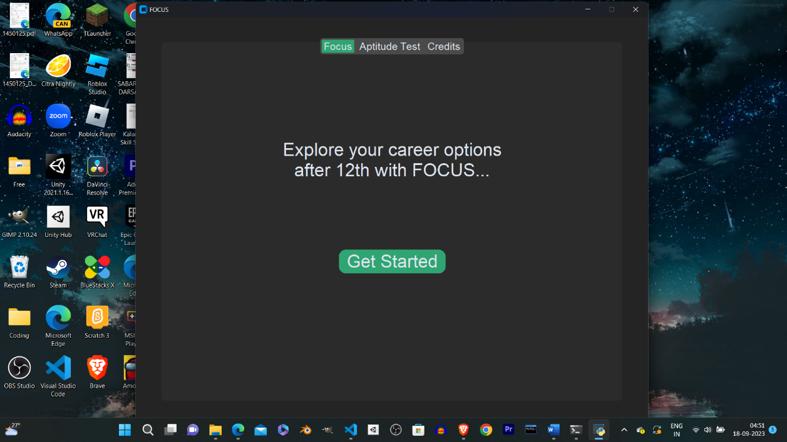

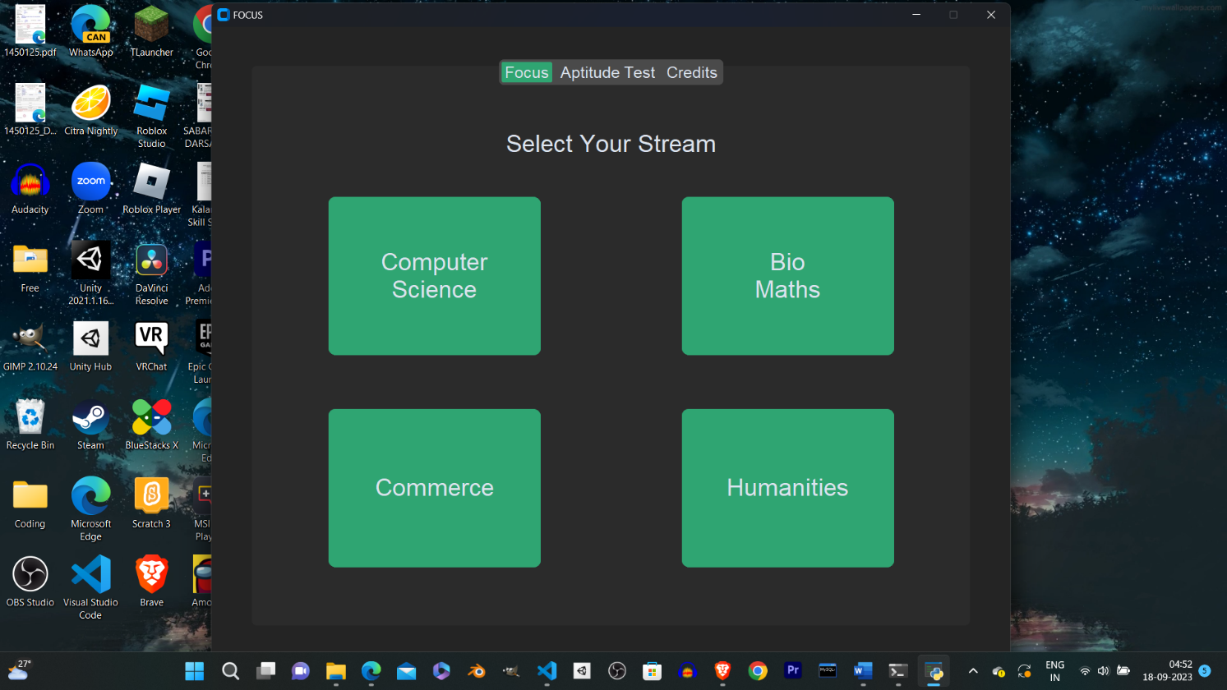

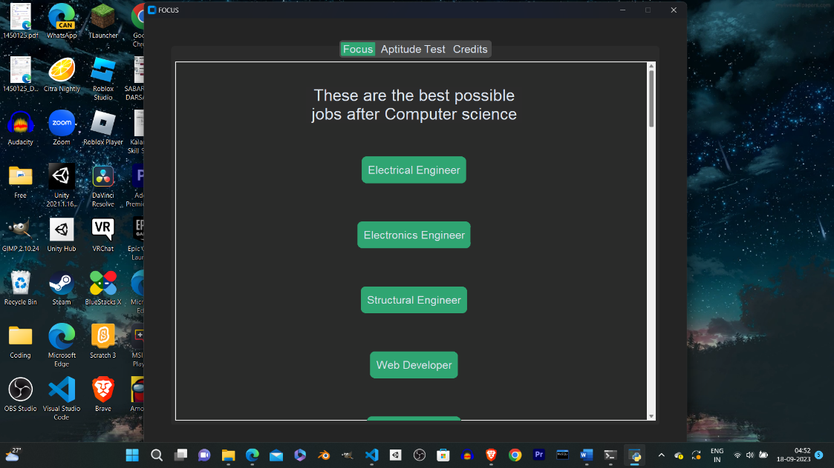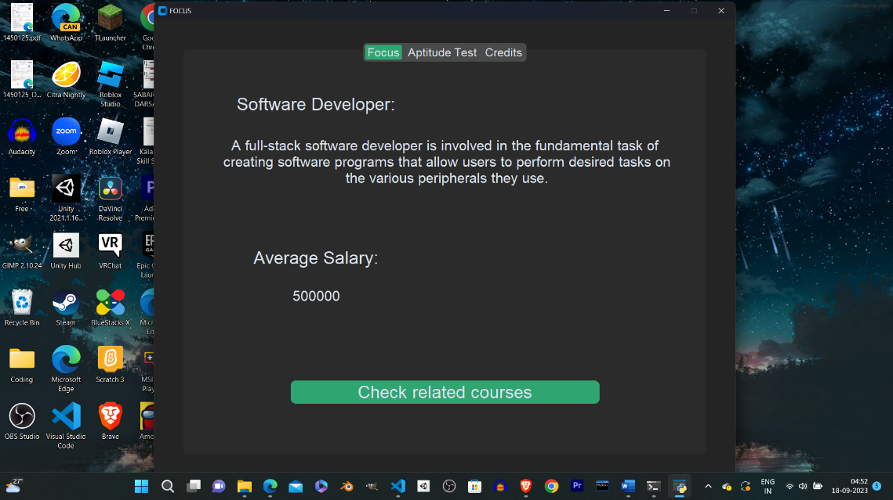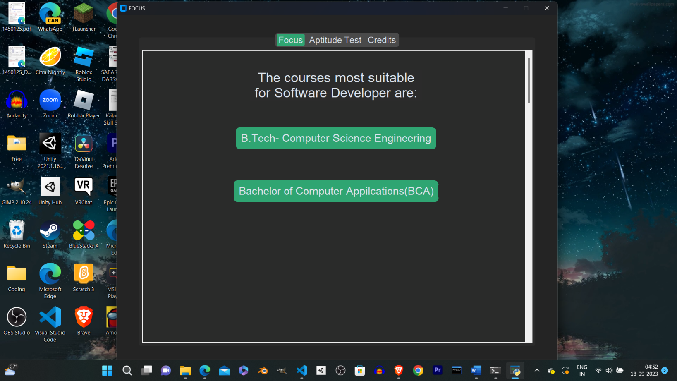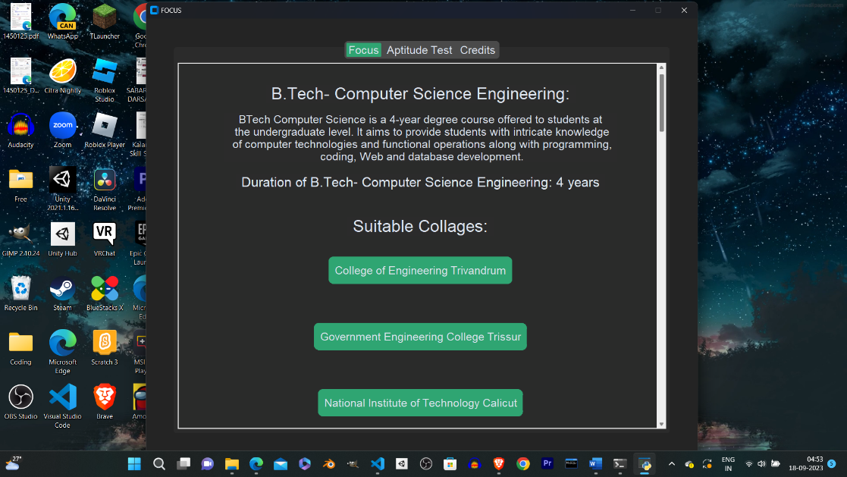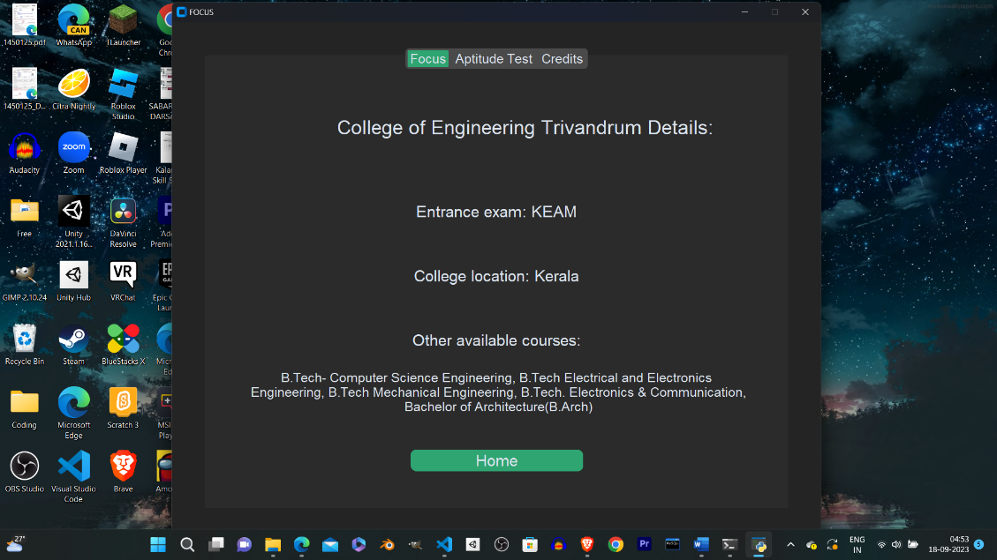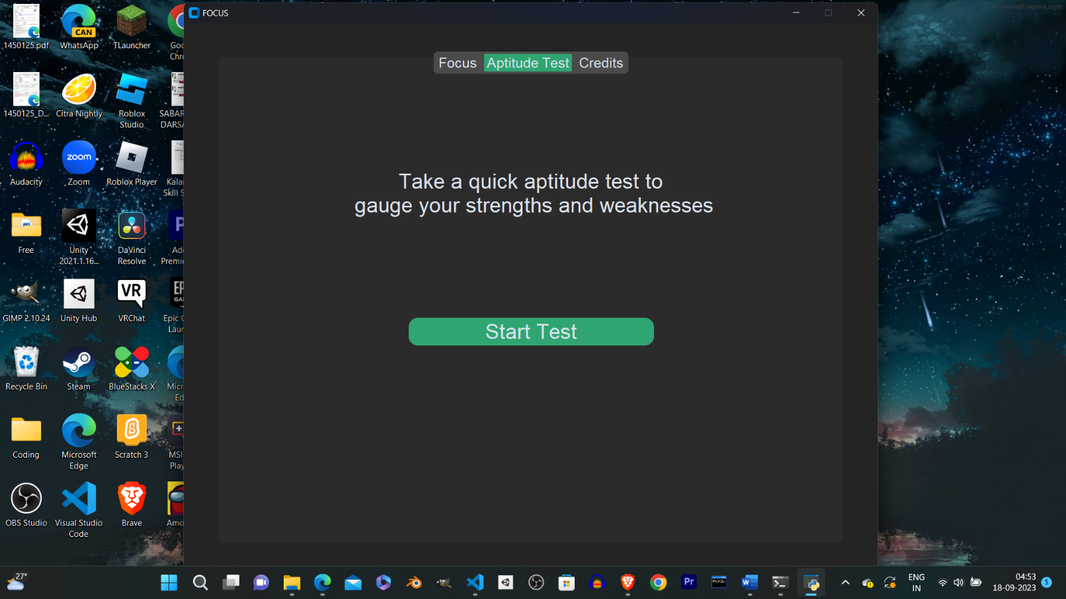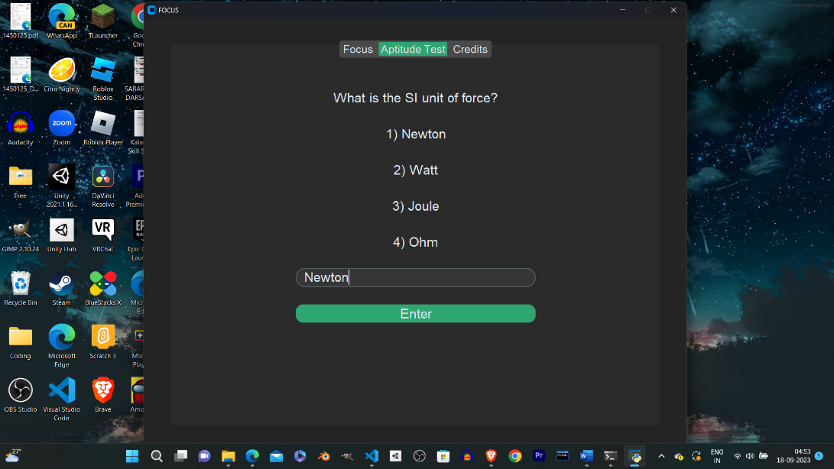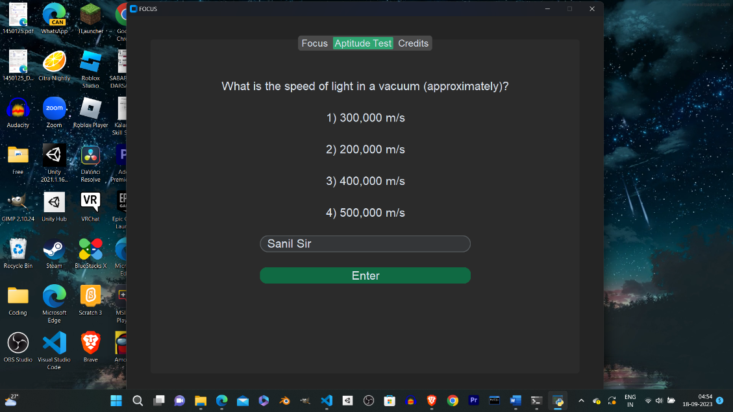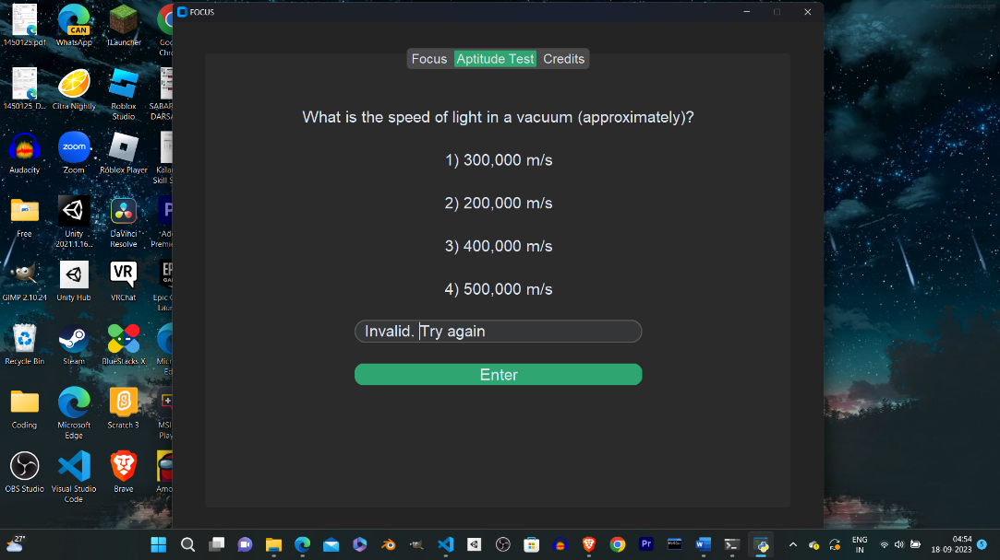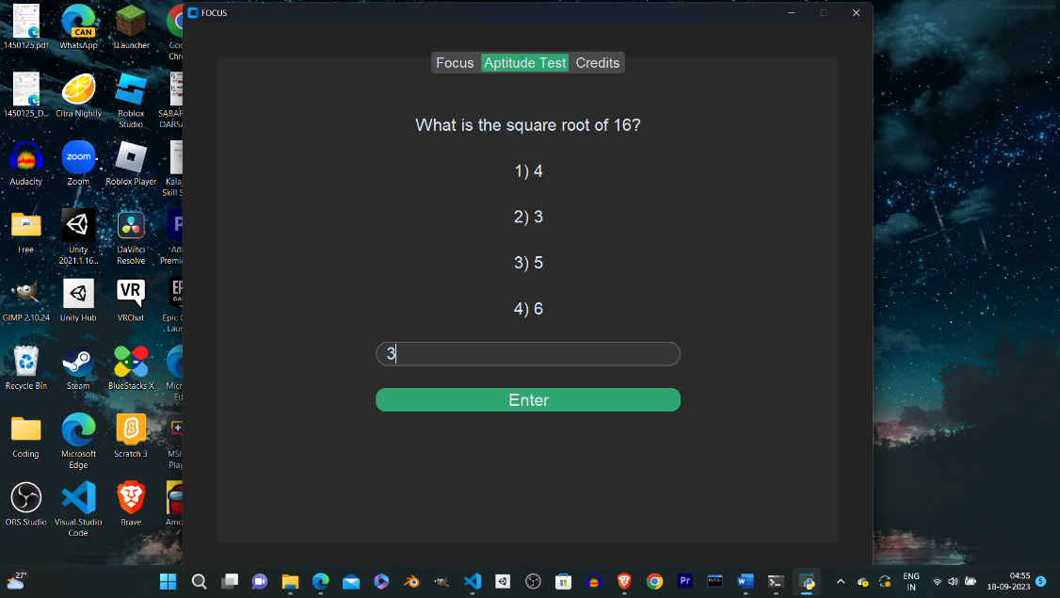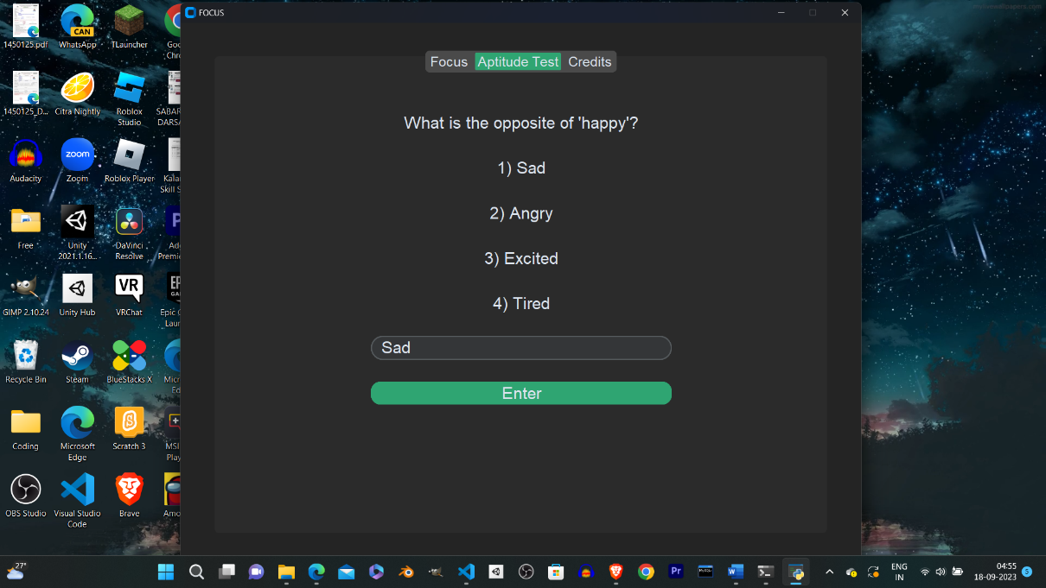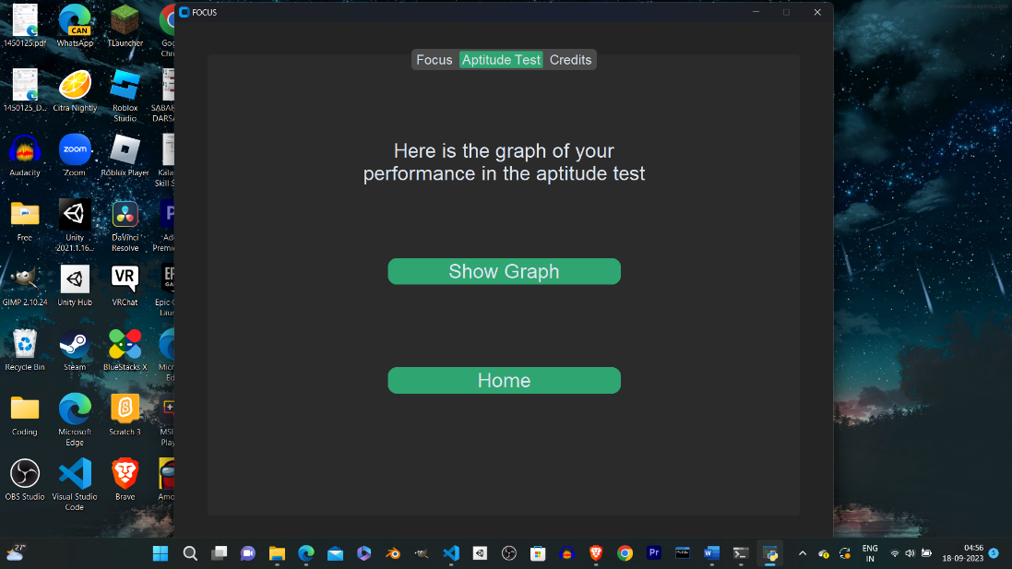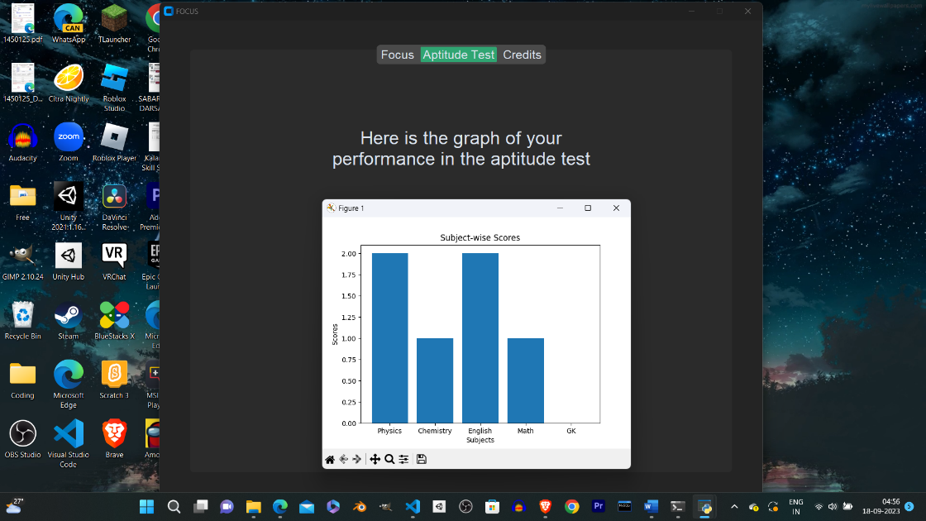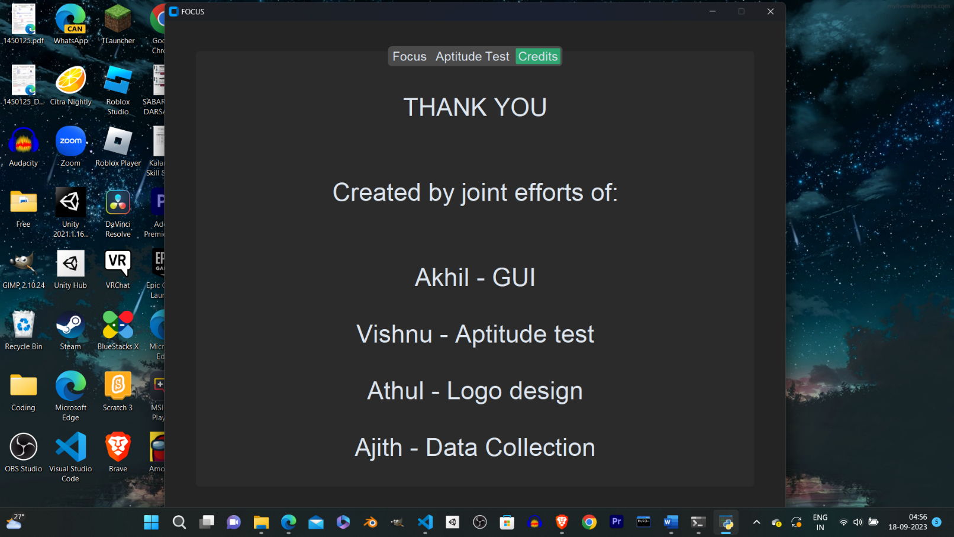

## FUTURE ENHANCEMENTS

1. A new tab comprising of graphs and statistical data to help users make their career decisions even better
2. Code Quality can be improved
3. More Data can be added to give the users even more options to decide from

## CONCLUSION

The Python-MySQL program titled “Future Opportunities and Career Understanding System(FOCUS)” project has been submitted in fulfillment of the main project as part of COMPUTER SCIENCE stream of Senior Secondary Education rules and CBSE.

## ANNEXURE

* 1. **Vishnu S**
  2. **Athul Krishna S**
  3. **Ajith A**
  4. **Akhil Krishna A Pillai**

## BIBLIOGRAPHY

1. COMPUTER SCIENCE text book By: PREETI ARORA
2. https://customtkinter.tomschimansky.com/documentation/
3. stackoverflow.com
4. collegedunia.com
5. https://github.com/TomSchimansky/CustomTkinter